Quick Reference

**Matching Sound to Animation**

(<http://www.alice.org/resources/how-tos/matching-sound-to-animation/>)

**Programing the Animation and Sound**

* Create a do together and place both the animation and sound in that same do together

**Adjusting the Synchronization**

**Aligning a short audio clip after the start of an animation**

* Drag a do in order into the code editor and place the playAudio procedure along with a delay.
* Set the duration of the delay to however many seconds you would like to wait.

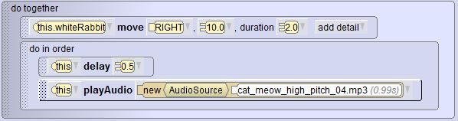

**Stretching an animation to match the duration of the audio**

* Us the add details drop down to add duration to your procedure and set it to the length of the audio.
* When aligning the audio duration with a set of animations you can add all the procedure durations together to reach the audio length.

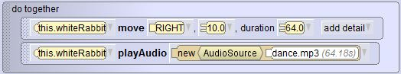

**Matching a sound that is long to an animation that is short**

* Edit the stopping and starting points of a sound by clicking Custom Audio Source on the drop down tab.
* In the custom audio editor you can adjust the starting and stopping point of the sound by dragging the starting marker and stopping marker slider.

