Quick Reference

**The Basics of Using Audio**

(<http://www.alice.org/resources/how-tos/the-basics-of-using-audio/>)

**Importing Audio**

* Importing audio can be done in one of two ways:
* Go to the project tab, then resource manager. In the resource manager window press import audi*o*

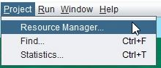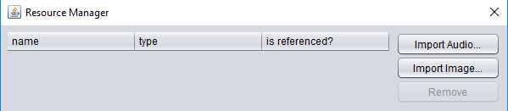

* OR Drag the playAudio Procedure into the Code Editor and a drop down menu will appear. Select Import Audio



* Navigate to the file you want and select. Be aware that Alice will only play .wav and .mp3 files. See how to change audio files using Audacity to help change file types if needed. Other file types may not be visible when searching for the file.

**Playing Audio**

* Drag the playAudio procedure into the code editor.
* Audio files that you have already imported using the resource manager or using the import audio drop down will populate the drop down list and can be reused or you can select import audio and add a new file.
* The playAudio procedure can be found on the procedure list for any object. The object calling the audio file will not impact in any way the audio playback. Any object can be used including the scene or camera.

**Editing Audio**

* Select the playAudio drop down menu and select Custom Audio Source.

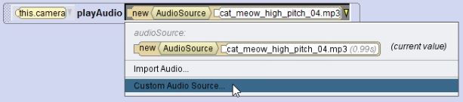

* You will be taken to this window.

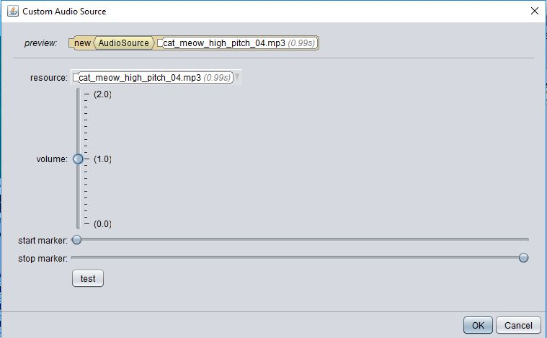

* **Adjust the volume** of the sound by dragging the volume slider up and down.
* **Adjust the starting point** of the sound by dragging the start marker slider to the right.
* **Adjust the stopping point** of the sound by dragging the stopping marker slider to the left.