Assessment

The Alice Code Editor

# Provide Definitions of the Following

# Programming Terms

Procedure Parameter

Method Sequential Processing

Procedural Method Conditional Execution

Functional Method Iteration

Argument Comments

# Alice Terms

Code Editor Do in order

Camera View Do together

Control Panel Methods Panel

Control Structure Disable Code

# Questions

1. What are the basic elements of programming?
2. What is the difference between a procedural and functional method?
3. What is a control structure?

# Code Editor Map

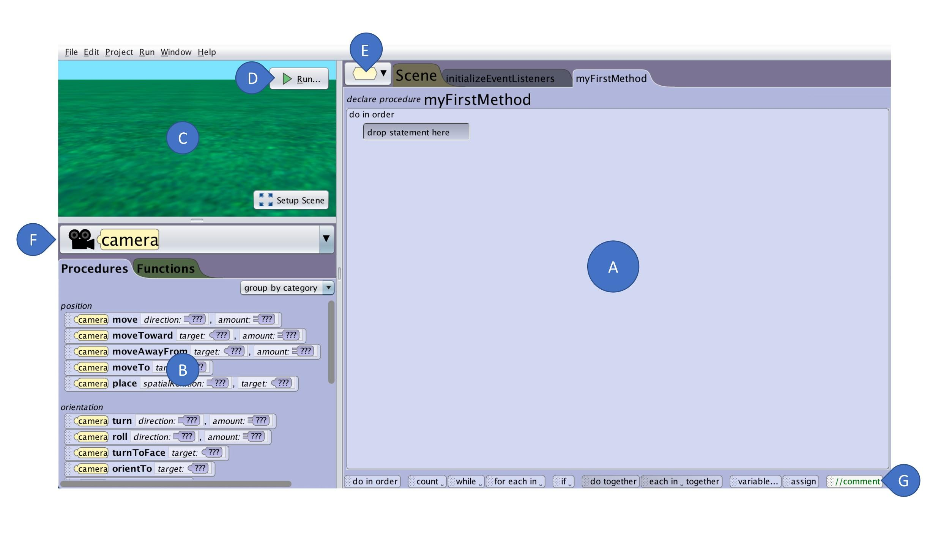

***Place the appropriate letter next to the listed element of the Alice 3 Scene Editor***

|  |  |  |  |  |  |
| --- | --- | --- | --- | --- | --- |
|  | **Methods Panel** |  | **Code Editor** |  | **Start Program** |
|  | **Object Menu** |  | **Control Panel** |  |  |
|  | **Code Editor Tabs** |  | **Camera View** |  |  |