Design Document

**Interactive Narrative Example**

# Summary

This is an example of an interactive narrative that was created by students working for the Alice Team. It can serve as an example of the design process and the types of documentation that can be created when following the approach found in the Design Process Interactive Narrative lesson. It is annotated to show some of the design thinking and feedback that went into the final design.

# Step 1: Problem Statement

The student was challenged with the following design constraints when brainstorming their idea:

* Create cool examples of an open world interactive narrative using the following programming elements
  + Collision Detection
  + Proximity Detection

The pitch for this project by the student began with:

“I want to create a world where the player brings flowers back to life by interacting with them”

This pitch went through several further design ideations when pressed on “why am I doing this?”

You are a Goddess of rain helping a gardener bring her flowers back to life.

~~A world where a person can help a farmer save their farm~~

~~You are an astronaut trying help save a dying world~~

~~You are an adventurer on a new planet exploring and learning about an alien ecosystem~~

~~You are a Botanist learning about a new flower by interacting with it~~

At the end of the first brainstorm and pitch the problem statement for this world was:

“I want to build a world where the player is a Goddess of rain helping a gardener bring her flowers back to life”

It was given the title: Evergarden

# Step 2: Understand the Problem

The next step was to break down their problem statement further to start to plan for how they will realize their idea. They were first challenged to answer the following questions to better understand and think about the underlying story:

Who: Goddess of Rain

What: You need to water the flowers to bring them back to life

Where: A garden

Why: The flowers are dying because of a drought

Since this was going to be an open world interactive narrative the student chose to use a world map to start to think through the experience.

### World Design

##### **World design map V1**:

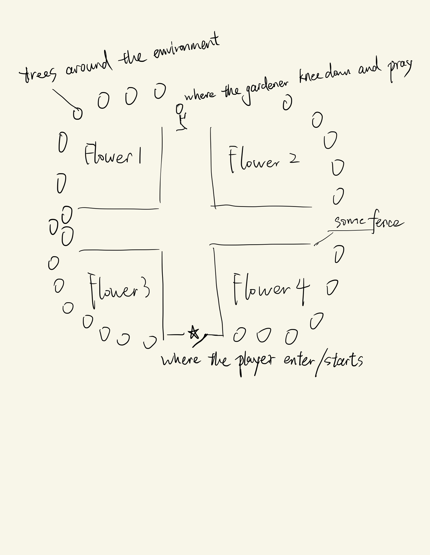

This design was pitched with the player starting at the star and being free to go into each of the 4 different areas to interact with different types of flowers. The feedback was that the player may just walk straight ahead to the end of the experience without interacting with any of the areas. How could we design this so that the player was guided through the exploration and could be given the freedom to move around but still advance through a narrative. So the map was redesigned.

##### **World design map V2**:

In design map V2, we are seeing a more linear experience rather than a flat one. The map was divided into three areas in sequential order, each of which has a different interaction with different types of flowers. This layout allows the player to be guided through different interactions.

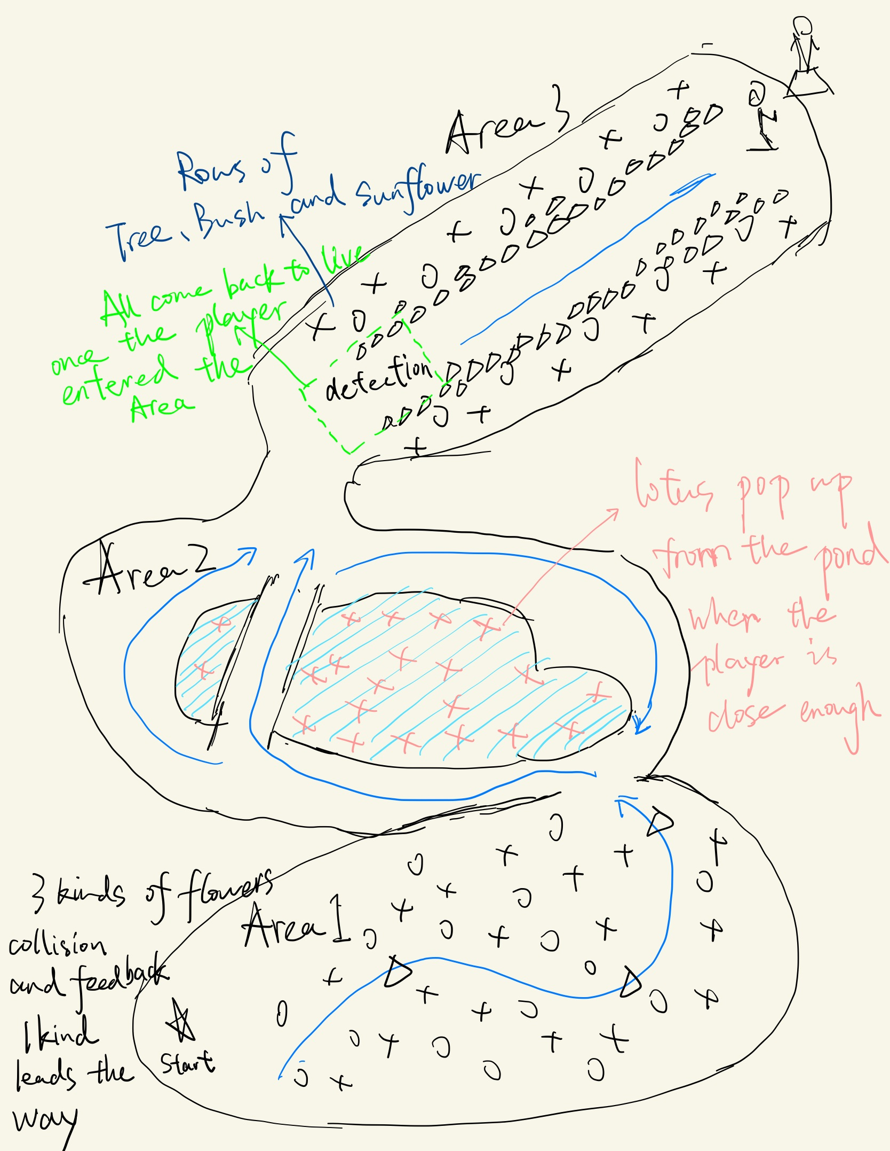

### Narrative Development

At the same time the world and the different player interactions were being laid out the story was also being pushed forward. For this part it made more sense to use storyboards to think about the key story moments that happen at the locations called out in the world map (the cut scenes).

#### Starting Animation

The decision was made to have both a start animation and an end animation. The start animation will set up the story for the player to know who they are and what they are doing.

##### Start animation storyboard:

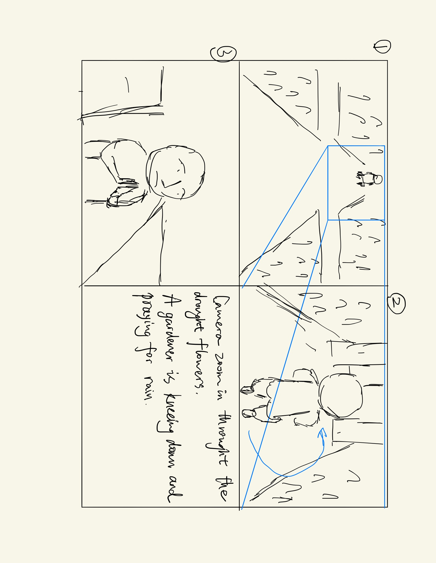

The storyboard calls out that the intro begins with a fly through of the wilting flowers area to give set-up. Conversation around this storyboard questioning how the player would know who they were in this experience led to the idea of having a ghost version of the statue come to life and fly the player back to the beginning of the world to help the player know they are the rain goddess and to smoothly transition them back to the starting location.

##### Starting Animation Script:

There was a short script created to complete the dialogue of the gardener praying to the statue of the rain goddess to save the flowers. It was expanded to call out the camera moves to give more information to the storyboard.

OPENING: Background Music and Nature Audio playing. CAMERA looking at flowers.

CAMERA turns to the right and altar to the RAIN GODDESS with GARDENER praying before the statue of the RAIN GODDESS comes into frame. (GARDENER has his back to the camera)

CAMERA pans over landscape to the RAIN GODDESS/GARDENER. Camera frames RAIN GODDESS/FARMER.

FARMER (voice over): God of Nature, I just pray right now that you will help the poor flowers over here. The flowers are dying because of a severe drought. Please reveal yourself to them and bring them back to life.

CAMERA swings around to slightly behind the left of the statue to show front of GARDENER.

RAIN GODDESS avatar flies out of the statue (into area3) and CAMERA follows.

RAIN GODDESS pauses at flowers; CAMERA zooms in on flowers in area3.

RAIN GODDESS flies over the landscape to show birds eye view and hovers over area 2; CAMERA follows behind and slightly above.

RAIN GODDESS flies to the right and down to ground level in area1.

CAMERA flies to the left, faces RAIN GODDESS, and turns toward the trees.

CAMERA flies back, and behind RAIN GODDESS.

CAMERA positioned behind RAIN GODDESS for player interaction.

GAME STARTS. (PLAYER interaction starts.)

#### Ending Animation

The ending animation closes out the story and gives closure to the experience

##### End animation storyboard:

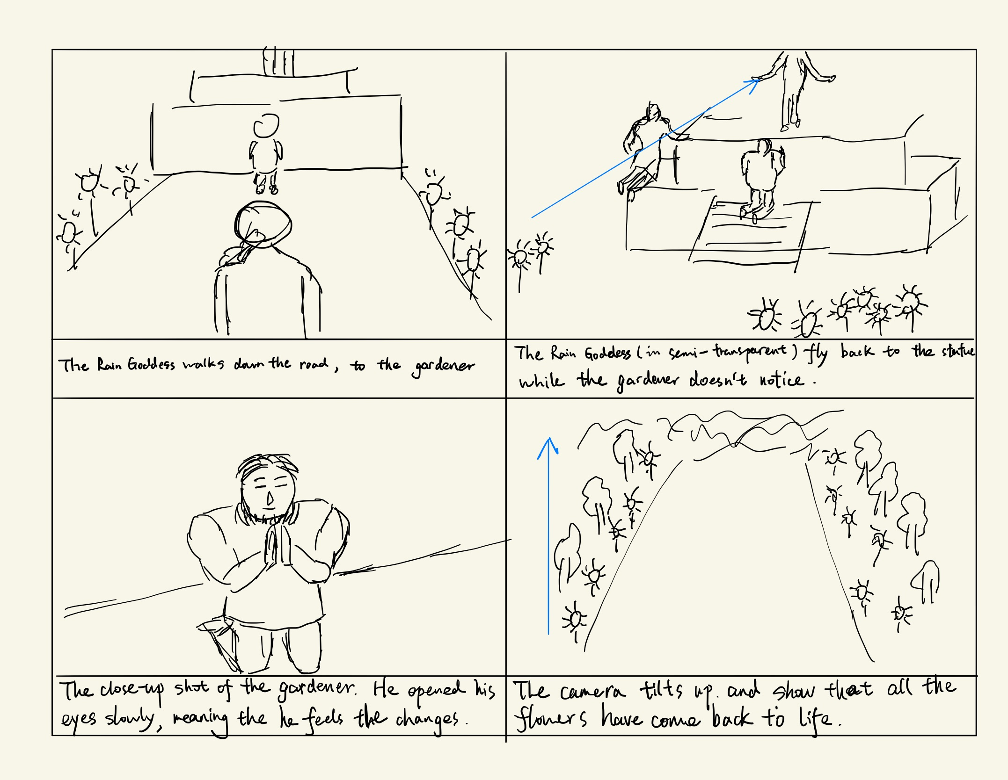

##### Ending Animation Script:

Again a script was added to the storyboard to support the information.

GAME ENDS. (PLAYER interaction stops.)

CAMERA positioned behind RAIN GODDESS.

RAIN GODDESS flies into the altar/statue.

CAMERA turns to face the GARDENER

(GARDENER opens eyes and eyes grow wide)

ENDING: CAMERA pans up to show the garden in bloom. Background music and Nature Audio end.

### Interaction Design

First the student outlined that the player would move around the world using standard key presses for moving and turning around the space. With separate interactions designed for each area.

#### Player Controls

PLAYER uses arrow keys to move RAIN GODDESS

Forward Arrow Key to move CAMERA/RAIN GODDESS forward

Left Arrow Key moves CAMERA/RAIN GODDESS left

Right Arrow Key moves CAMERA/RAIN GODDESS right

#### Area Interactions

The student wrote out descriptions of the experience they envisioned for each area.

#### Area One Player Interaction

There are two types of interaction in the first area:

Normal flowers: There are two kinds of normal flowers all over the area1. And the interaction between them and the character is simple -- when they are touched by the character, their color will change from dark gray to vivid color.

Guide flowers: There are three guide flowers hidden in the area1. At first, the player can only see the first one. When the first one is touched by the player, it will disappear and the second one will show up several steps in front of the character. And when the second one is touched, the third one will pop up. In this way, the guide flowers can lead the player through area1.

#### Area Two Player Interaction

There is a pond in the area3 and there are some lily pads hidden under the pond. Each one of the lily pads can individually detect the distance between the player and itself. When the player gets close enough to one of them, it will pop up from the pond.

#### Area Three Player Interaction

There is a straight road in the area3, along which there are some trees and sunflowers. When the player steps on the road, all the trees and sunflowers will change color from dark gray to vivid color one by one sequentially. After the color wave, if the player is walking along the road, there are hidden checkpoints. Each one of them will cause size changes in the sunflowers.

# Step 3: Design a Solution

The next step was to translate the design documents created above into a plan for the program.

### Designing the World

Since the design approach included making fairly detailed world maps no further planning was needed before implementing the scene.

### Designing the Program

#### Player Controls Algorithm

The student made a quick algorithm design for the programming of the controls.

PLAYER uses arrow keys to move RAIN GODDESS

If Forward Arrow Key hit then CAMERA/RAIN GODDESS moves forward

If Left Arrow Key hit then CAMERA/RAIN GODDESS moves left

If Right Arrow Key hit then CAMERA/RAIN GODDESS moves right

#### Area Interaction flow Charts

The student chose to use flowcharts to plan the program for each area interaction. Each area has a flow chart that explains the conditional programming that would be needed to build the interactions outlined above.

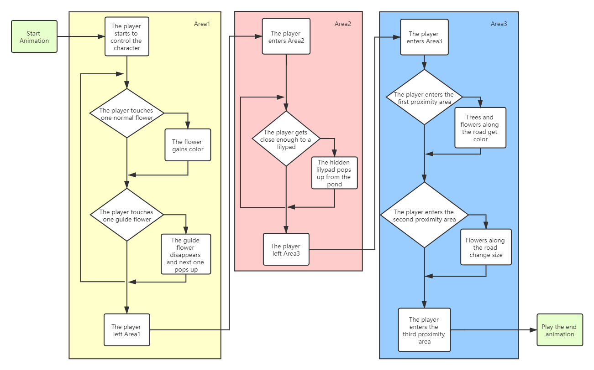

#### Cut Scene Animations

Text based algorithm design was used to plan the programs for the opening and ending animations.

##### Opening Animation Algorithm

OPENING: Background Music and Nature Audio playing. CAMERA looking at flowers.

CAMERA turns to the right and altar to the RAIN GODDESS with GARDENER praying before the statue of the RAIN GODDESS comes into frame.

CAMERA moves over landscape to the RAIN GODDESS/GARDENER. CAMERA frames RAIN GODDESS/FARMER.

**Do Together:**

FARMER (voice over): God of Nature, I just pray right now that you will help the poor flowers over here. The flowers are dying because of a severe drought. Please reveal yourself to them and bring them back to life.

CAMERA turns backward to look up at the Statue.

CAMERA turns around slightly behind the left of the statue to show front of GARDENER.

**Do Together:**

RAIN GODDESS avatar moves forward out of the statue (into area3)

CAMERA follows.

RAIN GODDESS pauses at flowers

CAMERA zooms in on flowers in area3.

**Do Together:**

RAIN GODDESS moves over the landscape and hovers over area 2

CAMERA follows behind and slightly above.

**Do Together:**

RAIN GODDESS moves to the right and down to ground level in area1.

CAMERA moves to the left, faces RAIN GODDESS, and turns toward the trees.

CAMERA moves back, and behind RAIN GODDESS.

CAMERA moves behind RAIN GODDESS for player interaction.

GAME STARTS. (PLAYER interaction starts.)

##### Closing Animation Algorithm:

GAME ENDS. (PLAYER interaction stops.)

CAMERA positioned behind RAIN GODDESS.

RAIN GODDESS moves into the altar/statue.

CAMERA turns to face the GARDENER

(GARDENER opens eyes and eyes open wide)

**Do Together:**

CAMERA turns up to show the garden in bloom.

Background music and Nature Audio end.

# Step 4: Implement Design

#### Prototyping

Since this world had several different interactions in the world it was decided to do quick prototypes of each interaction first to make sure they would work and look cool. They were then all assembled into the final project. Each of these prototypes helped to iterate the design of how they were programmed and how they looked in order to fine tune them before bringing all of the parts together.

flowerChangePrototype - This prototype tested the collision detection with the flower causing them to transition back to color.

flowerPathPrototype - This prototype tested the guide flower functionality - when the user gets close to the visible flower it disappears and a new guide flower appears ahead.

lillyPadPondPrototype - This prototype tested the proximity functionality for bringing the lilypads to the surface of the pond

finalHallwayCascadingChangePrototype - This prototype tested the transition of the chosen flowers and the functionality of having them transition based on distance from the user as they walk down the path

walkCycleImplementationPrototype - This was created to figure out the best way to add a walk cycle to the player movement

The final world still went through several design iterations based on testing that changed the layout to address things like:

* Always have the next guide flower in sight when one disappears
* Clump the flowers so that colliding with one flower will change a group of flowers to make it more dramatic
* Increase the proximity on the lilypads to make sure the player causes them to rise as they walk through the second area
* Change the trigger location and shape for area 3 to make sure the flower and tree transitions stay ahead of the player

#### Commenting

The commenting for the world evolved as the world was programmed to account for all the custom procedures within the world. Below are examples of what the comments in the program look like, but look at the world in order to see all of the comments that made it into the world.

The world includes commenting for event listeners that are important for basic functions of the game like Collision Events and Key Presses. Below is an example of commenting for the ArrowKeyPressedListener.

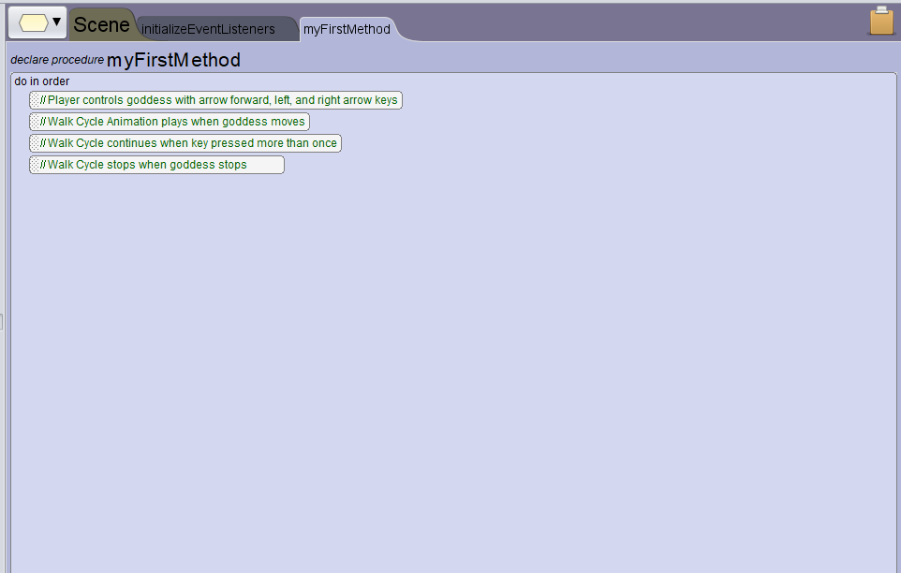

This world also implements ProximityEventListeners, like the example below when the player triggers the Lily Pads on the pond without colliding with the lilypads.

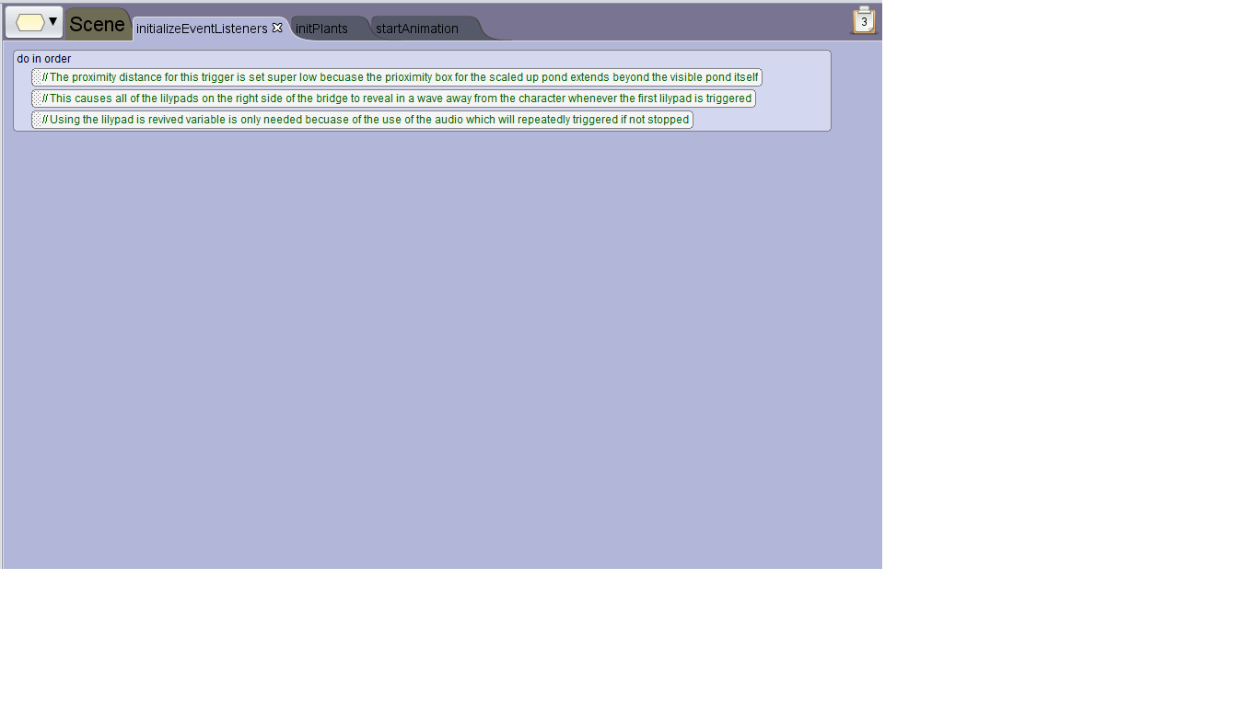

The example above also demonstrates a specialized procedure for the Lily Pads to trigger once the first lilypad is triggered and to stop the sound effects of the lily pads from playing once all the lily pads have appeared.

Take a look at the final world and see how all of this preproduction helped to make a really rich world that incorporates a very strong narrative. Though the payer is free to explore they are guided through the story and feel activated in the experience.

# Attachment: Design Document

The above is showing the design process. This section is the actual document that was created during the process. This document was a living document that was updated each time new feedback was incorporated or the components were edited so that it would reflect the final design.

### Title

Evergarden

### Story Concept

The player is a Goddess of Rain helping a gardener bring his flowers back to life.

### Creative Design

#### World Design



#### Narrative

##### Scripted Cut Scenes

###### Starting Animation:



OPENING: Background Music and Nature Audio playing. CAMERA looking at flowers.

CAMERA turns to the right and altar to the RAIN GODDESS with GARDENER praying before the statue of the RAIN GODDESS comes into frame. (GARDENER has his back to the camera)

CAMERA pans over landscape to the RAIN GODDESS/GARDENER. Camera frames RAIN GODDESS/FARMER.

FARMER (voice over): God of Nature, I just pray right now that you will help the poor flowers over here. The flowers are dying because of a severe drought. Please reveal yourself to them and bring them back to life.

CAMERA swings around to slightly behind the left of the statue to show front of GARDENER.

RAIN GODDESS avatar flies out of the statue (into area3) and CAMERA follows.

RAIN GODDESS pauses at flowers; CAMERA zooms in on flowers in area3.

RAIN GODDESS flies over the landscape to show birds eye view and hovers over area 2; CAMERA follows behind and slightly above.

RAIN GODDESS flies to the right and down to ground level in area1.

CAMERA flies to the left, faces RAIN GODDESS, and turns toward the trees.

CAMERA flies back, and behind RAIN GODDESS.

CAMERA positioned behind RAIN GODDESS for player interaction.

GAME STARTS. (PLAYER interaction starts.)

###### Ending Animation:



GAME ENDS. (PLAYER interaction stops.)

CAMERA positioned behind RAIN GODDESS.

RAIN GODDESS flies into the altar/statue.

CAMERA turns to face the GARDENER

(GARDENER opens eyes and eyes grow wide)

ENDING: CAMERA pans up to show the garden in bloom. Background music and Nature Audio end.

##### Interactive Narrative Elements:

###### Player Movement

The player uses keypresses to freely move around the world. Interactions with the world vary depending on the area of the world and types of flowers.

###### Area One Player Interaction

Normal flowers: There are two kinds of normal flowers all over the area1. And the interaction between them and the character is simple -- when they are touched by the character, their color will change from dark gray to vivid color.

Guide flowers: There are three guide flowers hidden in the area1. At first, the player can only see the first one. When the first one is touched by the player, it will disappear and the second one will show up several steps in front of the character. And when the second one is touched, the third one will pop up. In this way, the guide flowers can lead the player through area1.

###### Area Two Player Interaction

There is a pond in the area3 and there are some lily pads hidden under the pond. Each one of the lily pads can individually detect the distance between the player and itself. When the player gets close enough to one of them, it will pop up from the pond.

###### Area Three Player Interaction

There is a straight road in the area3, along which there are some trees and sunflowers. When the player steps on the road, all the trees and sunflowers will change color from dark gray to vivid color one by one sequentially. After the color wave, if the player is walking along the road, there are three checkpoints. Each one of them will cause size changes in the sunflowers.

### Technical Design

#### Scripted Elements

##### Opening Animation Algorithm

OPENING: Background Music and Nature Audio playing. CAMERA looking at flowers.

CAMERA turns to the right and altar to the RAIN GODDESS with GARDENER praying before the statue of the RAIN GODDESS comes into frame.

CAMERA moves over landscape to the RAIN GODDESS/GARDENER. CAMERA frames RAIN GODDESS/FARMER.

**Do Together:**

FARMER (voice over): God of Nature, I just pray right now that you will help the poor flowers over here. The flowers are dying because of a severe drought. Please reveal yourself to them and bring them back to life.

CAMERA turns backward to look up at the Statue.

CAMERA turns around slightly behind the left of the statue to show front of GARDENER.

**Do Together:**

RAIN GODDESS avatar moves forward out of the statue (into area3)

CAMERA follows.

RAIN GODDESS pauses at flowers

CAMERA zooms in on flowers in area3.

**Do Together:**

RAIN GODDESS moves over the landscape and hovers over area 2

CAMERA follows behind and slightly above.

**Do Together:**

RAIN GODDESS moves to the right and down to ground level in area1.

CAMERA moves to the left, faces RAIN GODDESS, and turns toward the trees.

CAMERA moves back, and behind RAIN GODDESS.

CAMERA moves behind RAIN GODDESS for player interaction.

GAME STARTS. (PLAYER interaction starts.)

##### Closing Animation Algorithm:

GAME ENDS. (PLAYER interaction stops.)

CAMERA positioned behind RAIN GODDESS.

RAIN GODDESS moves into the altar/statue.

CAMERA turns to face the GARDENER

(GARDENER opens eyes and eyes open wide)

**Do Together:**

CAMERA turns up to show the garden in bloom.

Background music and Nature Audio end.

#### Interactive Narrative Elements

##### Player Control Algorithm

PLAYER uses arrow keys to move RAIN GODDESS

If Forward Arrow Key hit then CAMERA/RAIN GODDESS moves forward

If Left Arrow Key hit then CAMERA/RAIN GODDESS moves left

If Right Arrow Key hit then CAMERA/RAIN GODDESS moves right

##### Area Interactive Elements

