Exercise

hello, world

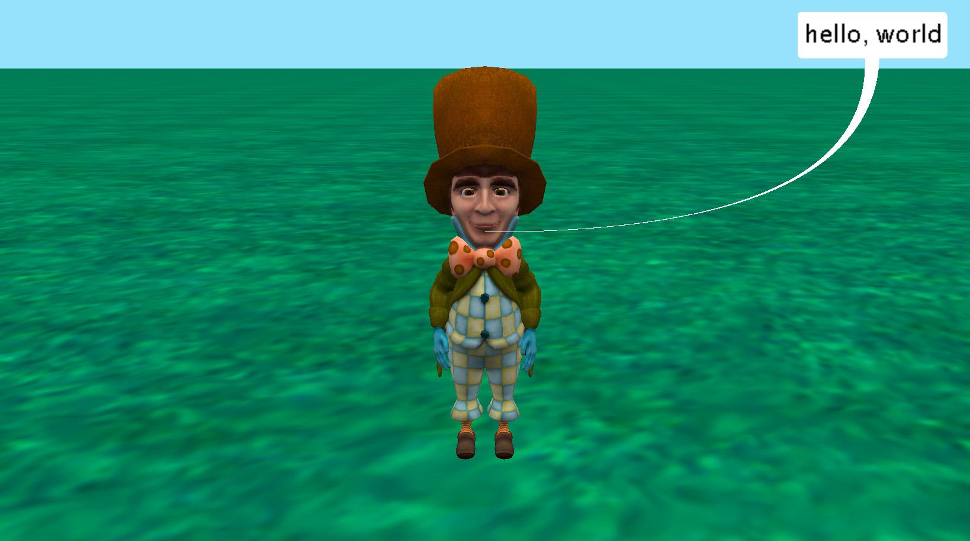

# Introduction – hello, world

This is an exercise for creating your very first Alice program. This exercise is good for creating your very first computer program or your very first computer program in Alice.

You may want to reference the lesson Programming in Alice or the Code Editor How to resources. These materials can be downloaded and printed for offline use from Alice.org

# The History of “hello, world”

A “hello, world” program has a long history in computer science. It is commonly used as a program that can be created to show that a programming environment is properly working but also to prove that you have learned enough about a programming language that you can make this program work and display hello, world.

This program has a long history with novice programmers as being their very first executed program. The actual origin of the program dates back to the late 1960’s and early 1970’s with some debate as to the very first use but has been attributed to Brian Kernighan and Martin Richards. It is documented as an example program in the book The C Programming Language.

#include <stdio.h>

main( )

{

printf("hello, world\n");

# Adding an Object to the Scene

The first step will be to add an object to your scene. You may wish to watch the Videos or check the Quick Reference Guides for the How To: *Adding Objects to a Scene.*

1. Start Alice
2. Select the a template from the Blank Slates section of the **Select Template Dialog** box.
3. Click on the *Setup Scene* button to go to the **Scene Editor** of Alice.
4. Add a character of your choice by double clicking it and adding it to the center of the scene or dragging and dropping it into the world
5. Click on the Edit Code button to return to the Code Editor

# Adding a Procedural Method (Code Statement)

Next you will write your very first Alice program. You may wish to watch the Videos or check the Quick Reference Guides for the How To: *Using Procedures Overview.*

1. Select your character from the object menu of the methods panel.
2. Drag the **say** tile into the *myFirstMethod* tab of the editor.
3. Select the Custom TextString from the pop up drop down.
4. Input “hello, world” in the input field.
5. Save the project.

# Run Your Program

Next you will run your program and officially become an Alice/Computer programmer!

1. Press the **Run** button found on the camera view window.

Congratulations!