Quick Reference

**Adding Background Music**

(<http://www.alice.org/resources/how-tos/adding-background-music/>)

**To Add Background Music**

* Go to the InitializeEventListeners Tab
* Click the drop down menu for Add Event Listener and choose Scene Activation/Time and then addSceneAcivationListner
* Drag your playAudio procedure into the newly created addSceneActivationListener

**To Make The Sound Loop**

* Drag a “count” function into the “addSceneActivationListener” and declare the number of loops you would like

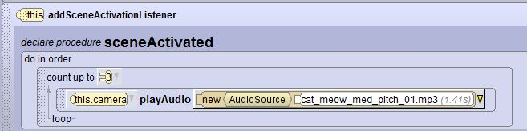

* Drag a “while” function into the “addSceneActivationListener” and select true. This will make it loop for as long as the program is running

