Adding Objects to a Scene

# The Gallery

The **Gallery**, in the Scene Editor, contains classes for creating and animating objects in an Alice project. Each class is a 3D model for building an object of a specific type (for example, an Alien or a MadHatter).

# Gallery Organization

The **Gallery** dialog box has six tabs and the **Browse Gallery by Class Hierarchy** tab is automatically selected



* **Browse Gallery by Class Hierarchy** **–** organized by mode of mobility, how an object “gets around” in a scene.
* **Browse Gallery by Theme** **–** organized by region (amazon, far east, southwest) and by story context (for example, fantasy, wonderland)
* **Browse Gallery by Group –** organized in common storytelling categories (for example, Animals, Characters, Scenery)
* **Search Gallery –** provides a search box to find a specific type of model
* **Shapes / Text –** provides 3D models for adding geometric shapes, 3D text, and billboards (importing 2D images) to the scene
* **My Classes –** provides a list of existing user classes stored in Alice’s My Classes folder, found in the user’s Documents or Home directory

# Gallery Navigation Bar

The Gallery Navigation Bar provides a series of buttons and menus that allow you to quickly move to different sections of the Gallery

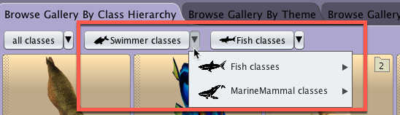

# Adding Objects to a Scene

* Place Object in the Scene
  + Click From Gallery in Scene Editor
    - Click on the class button in the gallery of the object you wish to add to the scene. This will place the object at the center origin point of the world x=0, y=o, z=o
  + Drag and Drop from Gallery in Scene Editor
    - Drag the class button into the camera view of the scene and place where you want using the yellow bounding box as a reference
  + Click Add Scene Property From Gallery in Scene Class of Code Editor. This will place the object at the center origin point of the world x=0, y=o, z=o
* Name Object
  + When the Add Scene Property from Gallery dialog box appears, name the object and click OK

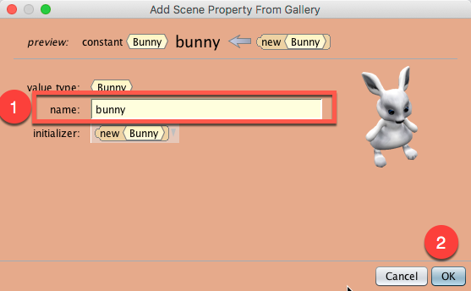

# Copying Objects in a Scene

* <ALT>-click and drag (Windows) or <CONTROL>-click and drag (OS X) - You are able to copy an object that is already in the scene

# Deleting Objects from a Scene

* Right Click on Object in Scene Window and Select Delete
* Right Click on Scene name in Object Tree in Scene Window and Select Delete
* Use drop down arrow on Object list in Scene tab of code editor and select Delete