Quick Reference

**Creating Custom Audio in Audacity**

(<http://www.alice.org/resources/how-tos/creating-custom-audio-in-audacity/>)

**Audio Capture and Clean Up**

* Open Audacity and make sure your microphone is plugged in
* Press the big red “Record” button to capture your voice or sound
* To Clean up your sound, highlight the part of the sound you do not want

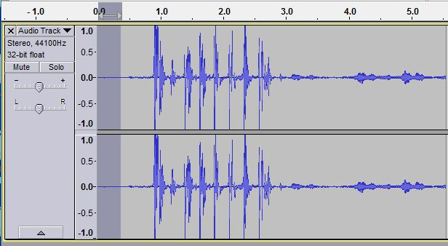

* Go to Effet and then Noise Reduction and select get sound profile in the window that pops up

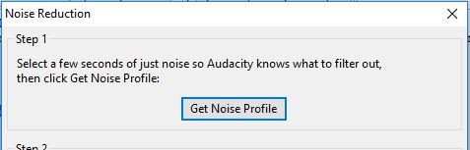

* Afterwards select your entire project (control +A)

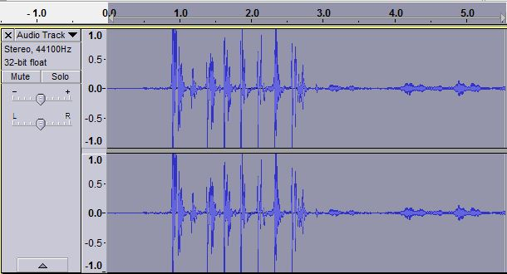

* Go back to Effect and Noise Reduction and select “OK” on the bottom right
* Your sound should be all set! You can now export it by going to File and Export Audio. You can then export it as a WAV or MP3