Positioning Objects in a Scene

# Handle Styles

When an object is added to the scene, it is possible to manipulate and orient an object in the scene using the **Handle Style** tools found at the top of the **Properties Panel.** Handle style controls create rings and arrows that can be used to modify the mouse's drag action in the Scene editor

|  |  |
| --- | --- |
|  | Click on the object and drag it forward, backward, left and right on the horizontal plane of the scene. Click and drag the turning handle to rotate the object left and right. |
|  | Click and drag the turning handles that surround the object to rotate the object left and right, forward and backward, and roll the object left and right. |
|  | Click and drag the arrows that appear to move the object in the direction of the arrow |
|  | Click and drag the arrow that appears to resize the object. Clicking and dragging the object itself will also resize the object when this Handle Style is selected |

# Keyboard shortcuts

When in the default handle style mode, it is also possible to use a modifier key and click and drag the object to position it in the scene

* Windows
  + **Shift + click and drag** will move an object up and down
  + **Control + click and drag** will turn an object left and right
* Mac OS X
  + **Shift + click and drag** will move an object up and down
  + **Option + click and drag** will turn an object left and right

# Scene Views

At the top of the Camera View window there is a menu that provides different perspectives of the scene. This is important in working in a 3D virtual environment to ensure that objects are in their appropriate relationship to each other.

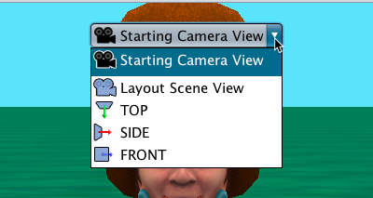

|  |  |  |
| --- | --- | --- |
| **Camera Viewpoint** | **Description** | **Camera Controllers** |
| **Starting Camera View** | The position of the camera when the project starts to run. This is the view that will be displayed in the code editor. | Default camera controllers as described above |
| **Layout Scene View** | Positions the camera upward and at an angle providing a useful perspective of the overall Scene | Default camera controllers as described above |
| **Top** | Presents an overhead view of a scene, the camera is hovering over the scene, pointing straight toward the ground in the scene. | The camera controllers allow moving the camera forward, backward, left, and right, up and down. But it is not possible to turn the camera to the left or right, forward or backward. |
| **Side** | The camera viewpoint faces the center point of the ground , from the ground's right side | The camera controllers allow moving the camera forward, backward, left, and right, up and down. But it is not possible to turn the camera. |
| **Front** | The camera viewpoint faces the center point of the ground, from the ground's front,. | The camera controllers allow moving the camera forward, backward, left, and right, up and down. But it is not possible to turn the camera.. |

# Using Objects One-shots

1. Select the object in the **Object Menu** of the **Properties Panel**.
2. From the **one-shots** menu, select **procedures**
3. From the list of procedures, select the procedure you wish the object to execute

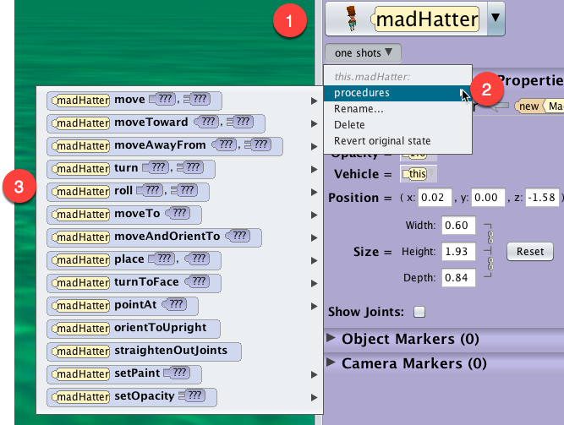

# Using Object Coordinates

It is possible to set the X, Y, Z coordinate position of the object, but this is a more advanced technique,

1. Select the object in the **Object Menu** of the **Properties Panel**.
2. Enter the X, Y, Z Position values in the appropriate text boxes

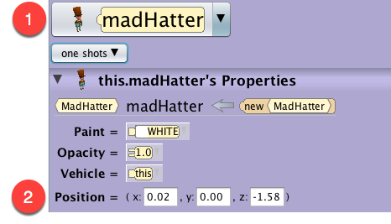

# Snap to grid

To align objects in a scene, activate the Snap grid in the Properties Panel. The Snap grid option displays a grid on the ground or water surface in a scene.

* By default, the grid is set to display grid blocks that are 0.5 meters on a side.
* Using the mouse to drag-and-drop an object will cause the object to snap into position at the nearest grid point.
* Rotating an object will cause the object to snap into position at the nearest 30 degree angle.
* The grid and angle snap values may be set to other values.

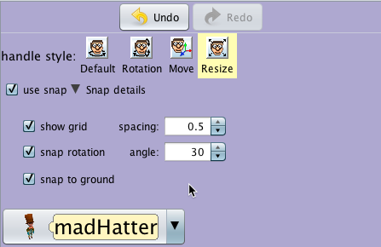

# Undo / Redo

* A click on the Undo button backtracks the most recent action and the state of the scene backs up one step, removing it.
* It is possible to click Undo repeatedly, backtracking all the way to the initial state of the project when it was first opened in this session (but not into previous sessions that were saved and later reopened).
* Click the Redo button to reverse the action of an Undo.
* Redo also provides the ability to repeat an action.

