Exercise

Tutorial: Control Structure Do Together

(<http://www.alice.org/resources/exercise-and-project/tutorial-control-structures-do-together/>)

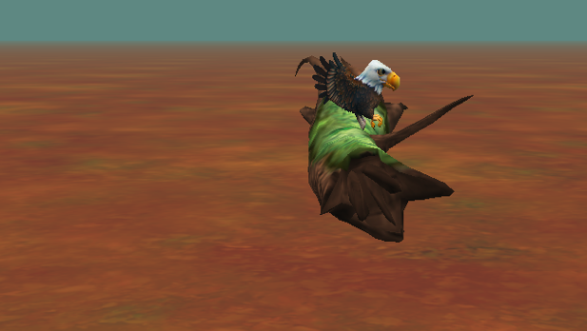

# Introduction – Eagle Hop

This tutorial exercise provides step-by-step directions for guiding you through using the basic Alice control structures *do in order* and *do together*. Here you will explore the basic use of control blocks and how *do in order* and *do together* can be used to make smooth movement animations in Alice. To do this you will build a basic scene with an eagle and a log and animate the eagle smoothly hopping up onto the log while at the same time flapping its wings.

You will need to access other printed materials or have access to the alice.org website to view the how to content called out within these materials. These materials can be downloaded and printed for offline use from Alice.org

Don’t forget to save your projects frequently

# Setting Up the Scene

First you will need to set up the scene with the Eagle and the jungle log. For the following steps, you may wish to watch the Video or check the Quick Reference Guide associated with the How To: Scene Editor Overview.

1. Start Alice. Select the NORTHWEST_FOREST template from the Blank Slates section of the **Select Template Dialog** box.
2. Go to the Scene Editor of Alice and add the *Eagle* object from the **Flyer** section of the Gallery to the Scene. From the Props section of the Gallery, add and position the *JungleLog*  -> new *JungleLog(LOG_BRIDGE)* object.
3. Position the *eagle* so that it is about 2 meters away from the center of the *log*, facing the log.
4. OR Download and open the project *FlyToLogSetup.a3p*, from the website.

# Using the *do in order* control structure

Next let’s animate the basic hop movement. For the following steps, you may wish to watch the Videos or check the Quick Reference Guides for the How To: *Using Procedures Overview*

1. Select the *eagle* and drag a **move** statement to *myFirstMethod* so that the object *moves* **up** ***1*** meters.
2. Drag a second **move** statement to *myFirstMethod* so that the *eagle* moves **forward** ***1*** meter.
3. Drag another **move** statement to *myFirstMethod* so that the *eagle* moves **forward** ***1*** meter.
4. Drag one more **move** statement to *myFirstMethod* so that the *eagle* moves **down** ***0.4*** meter.
5. Save the program. Before running the animation, on a sheet of paper, draw a diagram predicting what you think these code statements will do.
6. Run your program to see if your prediction is correct.
7. Rearrange the order of the statements in *myFirstMethod*, and make another prediction about what the eagle will do. Test your prediction by running the program.
8. Return the program statements to their original order.

# Using the *do together* control structures

Next let’s try to smooth out the animation to be more natural. For the following steps, you may wish to refer to the image above, or use your own ideas. You may wish to watch the Videos or check the Quick Reference Guides for the How To: *Using Do Together.*

1. From the **Controls** panel of the of the Alice 3 Code Editor, drag a *do together* code block into *myFirstMethod*.
2. Drag the first two statements (**move up 1 meter**, **move forward 1 meter**) into this *do together* code bock.
3. Draw another diagram predicting what you think your animation will now do.
4. From the **Controls** panel of the of the Alice 3 Code Editor, drag a second *do together* code block into *myFirstMethod,* **AFTER**the first *do together*.
5. Drag the remaining two statements (**move forward 1 meter**, **move down 0.4 meters**) into this *do together* code block.
6. Draw another diagram predicting what you think your animation will now do.
7. Rearrange the order of the statements inside the *do together* code blocks, and make a prediction about what the eagle will do. Test your prediction by running the program. Does rearranging the code INSIDE the do together code blocks make any difference in the animation? Why or why not?
8. Swap the order of the two *do together* code blocks (so that the second *do together* now executes first). Make a prediction about what the eagle will do. Test your prediction by running the program. Does rearranging the *do together* code blocks make any difference in the animation? Why or why not?
9. Return the program statements to their original order. Save and run the program.

# Using Nested Code Blocks

To make the flight of the eagle even more realistic, we would like to add a flying motion as the eagle takes off and lands. You may wish to watch the Videos or check the Quick Reference Guides for the How To: *Using Poses (Not Published Yet).*

1. Drag the **FlyingPose** statement into the first *do together* code block, as shown:
2. The eagle has another pre-defined pose called **foldWings** (found at the bottom of the procedures list). Add the **foldWings** procedure to the *do together* code block. Predict what you think will happen in the animation when you run the program.
3. You may be surprised to see that we do not see any flying motion at all. This is because in the do together, we are telling the eagle to get into a flying pose and close its wings AT THE SAME TIME. We must nest, or insert, a *do in order* code block into the *do together*, and drag the **flyingPose** and **foldWings** statements into this *do in order*. Predict what will happen before running the animation. Can you explain what is going on in this *do together*?
4. Nest a second do in order code (with flyingPose and foldWings) block inside the second do together code block, so that we get another flying motion as the eagle lands on the log.
5. Save and run your animation.

# Synchronizing Animations

After adding the wing flaps you may notice that the wings flap longer than the movement of the bird. For the following steps, you may wish to watch the Videos or check the Quick Reference Guides for the How To: *Using Procedures Overview* for editing details of procedures.

1. Change the ***duration*** value of each of the **move** statements (click on *add details* to set the duration) to 2 seconds.
2. Save and run your animation.