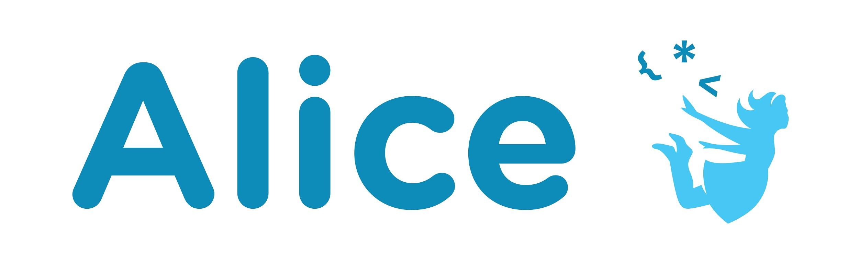Quick Reference

**Manipulating Biped Joints**

(<http://www.alice.org/resources/how-tos/manipulating-biped-joints/>)

## **Joints Overview**

Alright! Let’s talk Biped posing and animation. When animating in Alice, it is important to know how the joints work. As with human joints the primary way that joints move are to bend or pivot. In Alice these joint movements are achieved through the Turn and Roll procedures.

### Turn

Alice has been built so that the most common way you will want to manipulate biped joints will be the “turn” procedure.

thisJoint **turn** (*Direction)*, (*Amount)*

* Direction: you can choose from: left, right, forward, and backward.
* Amount: you can choose from the default list of decimal numbers or enter your own custom amount.

* The turn *amount* translates to the number of rotations. A “1” is equal to a full circular turn. While a character may be able to spin around multiple times few parts of the human body can do a full circular turn. A decimal number less than a 1 will be translated into a fractional amount of a full rotation. For example .5 will translate to ½ of a turn.

### Roll

Roll is less commonly used but will still be important for joints that can turn in all directions such as the neck or the shoulder.

thisJoint **roll** (*Direction)*, (*Amount)*

* Direction: you can choose from: left and right.
* Amount: you can choose from the default list of decimal numbers or enter your own custom amount following the same decimal representation of a percentage of rotation.

### Joint Orientation

To determine whether to use turn or roll it is important to understand the current orientation of the joint (forward/backward, up/down, left/right). In Alice each joint has its own orientation that is different than the orientation of the model. Forward for the shoulder joint is different than forward for the model. In Alice the general rule is that each joint points towards the next joint that it is attached to. For example forward for the shoulder joint points towards the elbow. Trial and error is one way to find out the orientation but there are also several ways you can view the joint orientation inside the scene editor:

* Turn on Show Joints - you can turn on show joints for a selected model in the properties panel while the whole object is selected (not available when a joint is selected). This will display lines that represent the different directions for the joints. It is also helpful to set the opacity to less than 1 to be able to see the joints inside the body.
  + White is pointing forward
  + Blue is pointing backward
  + Red is pointing right
  + Green is pointing up

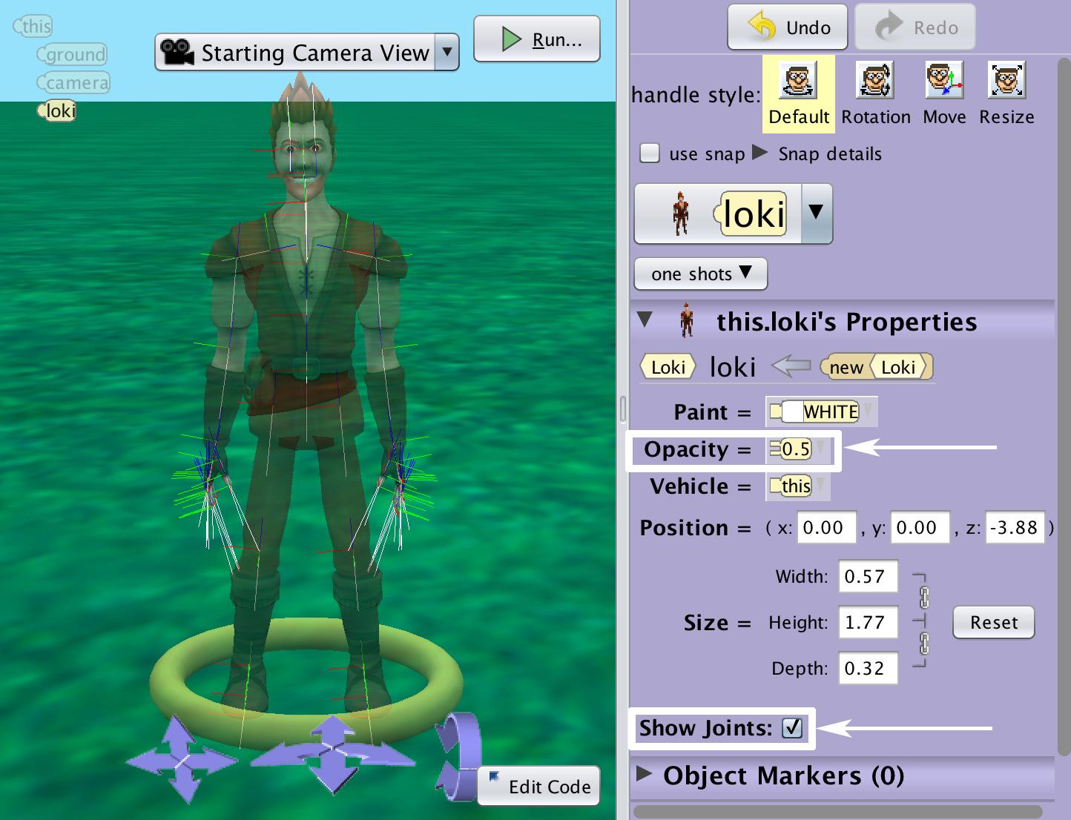

* Select a joint and choose the rotation handle - select the joint from the object drop down menu and select the rotation handle style. This will display the different colored rotation rings for the current position. The rings translate to:
  + Blue ring - show the orientation of the forward and backward turns
  + Red ring - shows the orientation of the right and left turns
  + White ring - shows the orientation of the right and left rolls

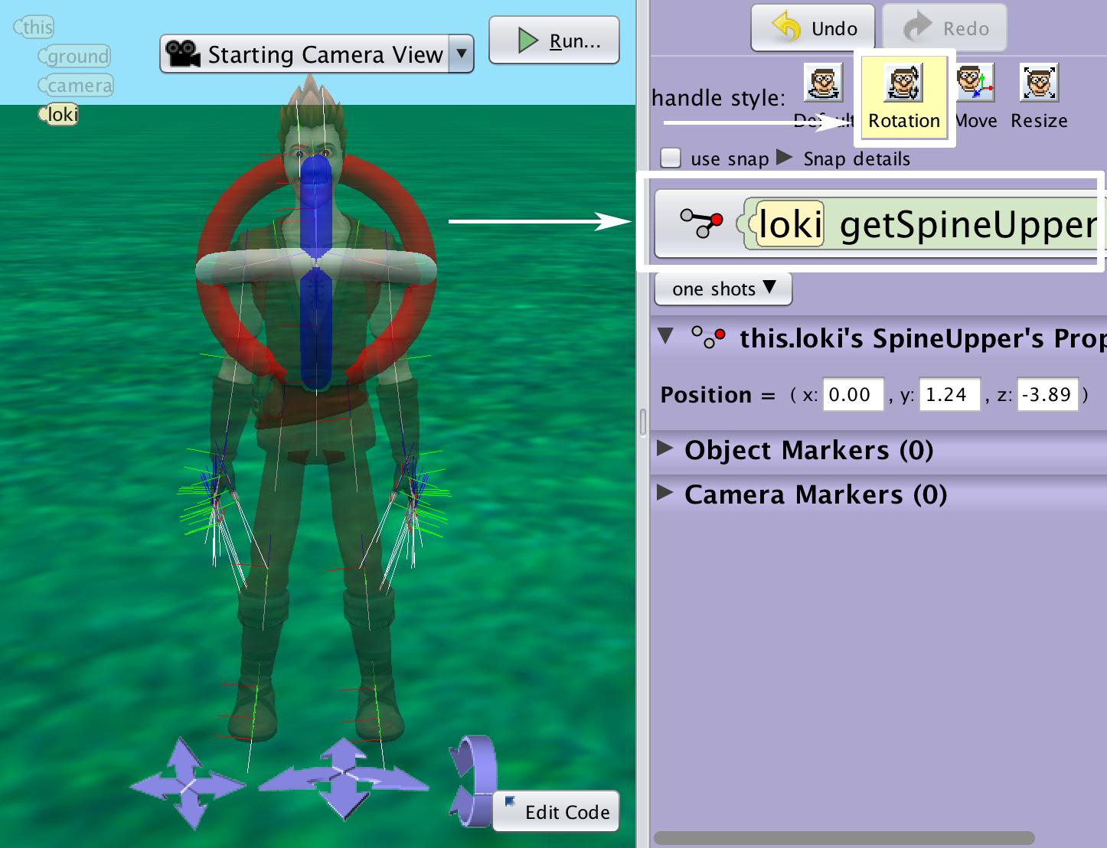

* It is important to remember that turning or rolling a joint will change the orientation and the effect of future manipulations based on that new orientation. It will also move all the joints that are connected to it which may change the orientation if other joints relative to the body. For example turning the shoulder will move the elbow joint in space which may change the way it in turns and rolls relative to the body.

### Joint Hierarchy

When you turn your shoulder your arm goes with it. This effect occurs in Alice as well. Certain joints will move all of the joints that extend out from it. In the biped there are two major branches and several minor branches of the skeleton.

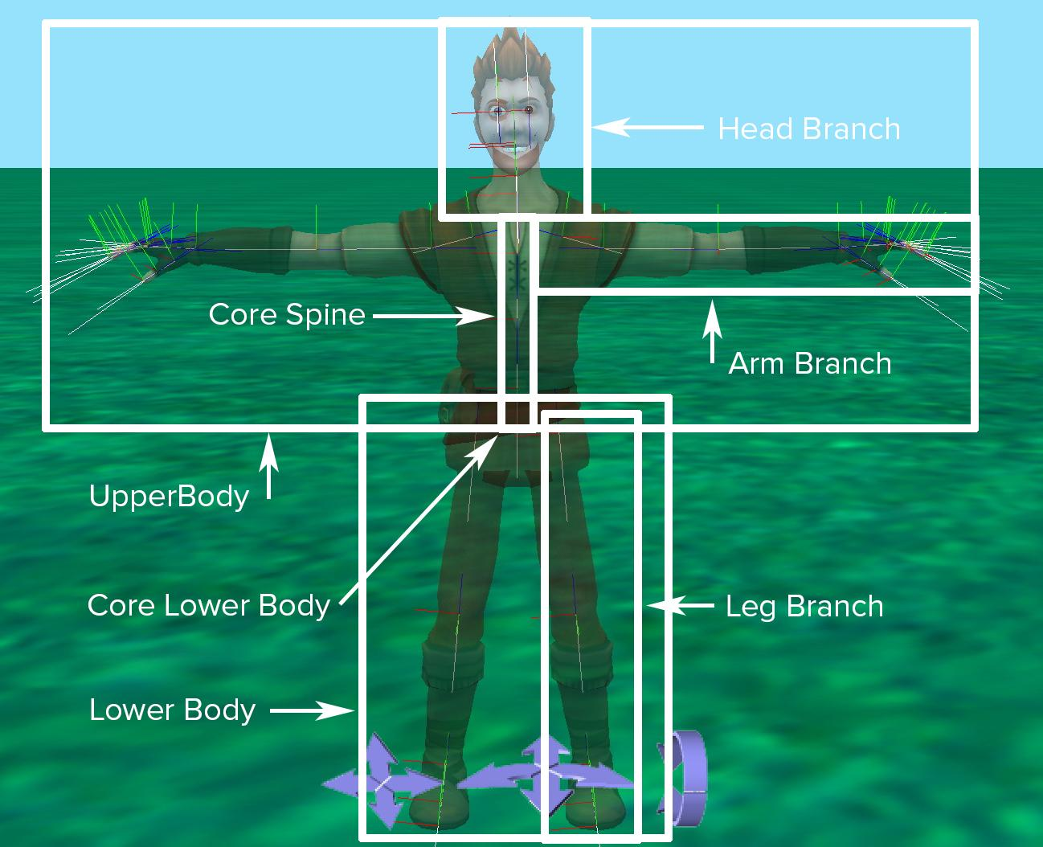

#### Upper Body

The upper body begins with the spine base joint and moves up the body and out through the limbs and the head. You will notice that when you turn or roll the spine base joint the whole upper body moves while the lower body remains stationary. Each joint of the upper body will impact the the joints further down the hierarchy in the following order:

##### Chest Trunk

Spine base > Spine middle > Spine upper > all upper body branches

##### Arm Branches (each separately)

L/R clavicle > L/R shoulder > L/R elbow > L/R wrist > L/R hand > L/R Fingers (each independent)

##### Neck and Head Branch

Neck > Head > Eyes, Eyelids and Mouth (these move with the head but work independent of each other as do special case bipeds that have ears or other head adornment joints)

#### Lower Body

The lower body begins with the pelvis and immediately branches down through the legs. Turning or rolling the pelvis will move the whole lower body while the upper body remains stationary.

##### Lower Body Core

Pelvis > Leg Branches

##### Leg Branches

L/R Hip > L/R Knee > L/R Ankle > L/R Foot

## **Animating a Biped**

When animating bipeds it is important to take into account how the human body (a biped) realistically moves. When turning joints in Alice think about how your own joints work in real life. How is a knee different than a shoulder? To raise your hand what joints do you turn to do it? Move your own limbs around and try to get a feel for how your joints turn! Knowing the differences between all of these different joints will help you understand how to best animate them in Alice.

To get you started here is a quick reference for the major joints (explore the fingers on your own). Keep in mind that these numbers and descriptions are based on the starting pose of the character. If you have already turned a joint the effects will be cumulative. It will be up to you to calculate how much turning or rolling your biped’s joint has already done and think about how that affects the next movement.

It is also possible that to achieve the movement that you want you will need to combine multiple turns and rolls at the same time. Don’t forget that you can use the doTogether control structure to have to procedures performed at the same time.

### Neck and Head Branch

#### Neck Joint

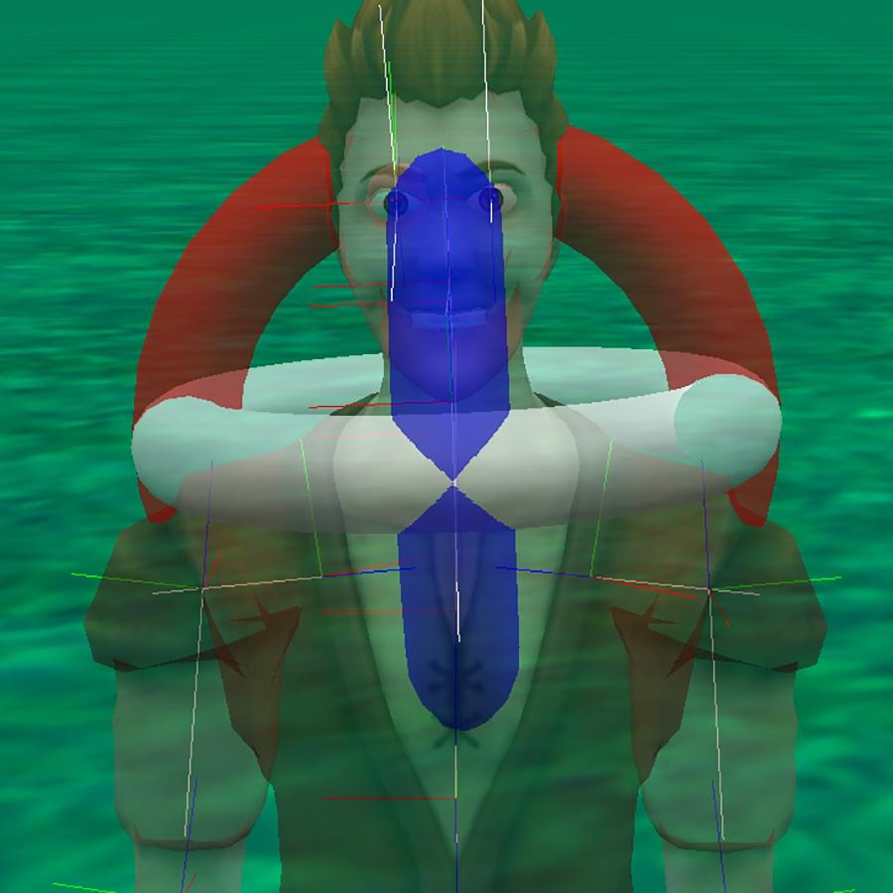

Description: This joint moves the neck of the character. The neck controls all of the joints extending into the head so when manipulating the neck you will move those joints accordingly.

Location: This joint is found at the base of the neck.

Orientation: The starting orientation of the neck joint has the forward direction pointing towards the head joint. The up orientation of the joint is pointing out through the back of the neck. This makes the direction of turns and rolls a little bit different than you might expect.

Natural Range Amount: For most of the neck amounts the natural range would not exceed .25 and would generally be less than .125

Common Turns and Rolls:

* Rolling right and left - will rotate the neck around the forward/backward axis of the neck (through the center of the neck from bottom to top). This will achieve the natural turning of the head to look right or left. Because of the orientation of forward and up the head turn relative to the body will be opposite the selected roll direction. A left roll will turn the head right relative to the body and a left roll will turn the head to the right.
* Turning forward and backward - will turn the neck around the left right axis (a line through both sides of the neck - think frankenstein's bolts). This will achieve a tilting forward or backward of the head. A forward turn will have the character look at it’s feet and backward towards the sky.
* Turn right and left - will turn the neck around the up/down axis of the joint (running through the front and back of the neck). This will achieve the natural cocking of the head to the side. Turning the head to the left will tilt the head to the left side of the character and turning to the right will tilt the head to the right.

#### Head Joint

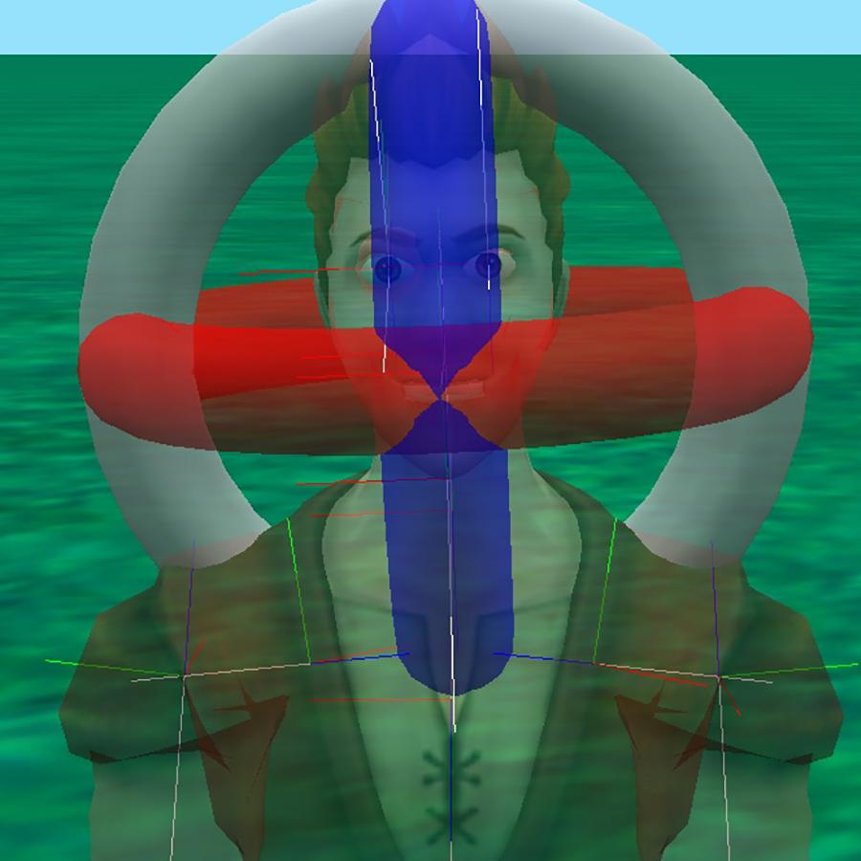

Description: This joint controls the whole head of the character. When moving your head it is more common that you would do so with your neck but the head joint can be used for turning the head left or right and for subtle cocking of the head but remember that changes to the head will not move the neck.

Location: This joint is found at the base of the head of the character.

Orientation: The orientation of the joint will be consistent with the orientation of the head with the the face representing forward and the top of the head representing up.

Natural Range Amount: For most of the head *amounts* the natural range would not exceed .25 and would generally be less than .125

Common Turns and Rolls:

* Turn right and left - will turn the head around the axis that runs up and down through the head (neck through the top of the head). This will achieve the natural turning of the head to look right or left.
* Turning forward and backward - will turn the head around the axis that runs through the head from left to right (through the ears) at the base of the head. This will achieve a tilting forward or backward of the head. Since the neck will not be moving it will appear more unnatural with larger movements.
* Rolling right and left - will rotate the face around the axis that runs forward and backward (through the face and back of the head) at the base of the head (chin). This will achieve the natural cocking of the head to the side. Since the neck will not be moving it will appear unnatural with larger movements.

#### Mouth

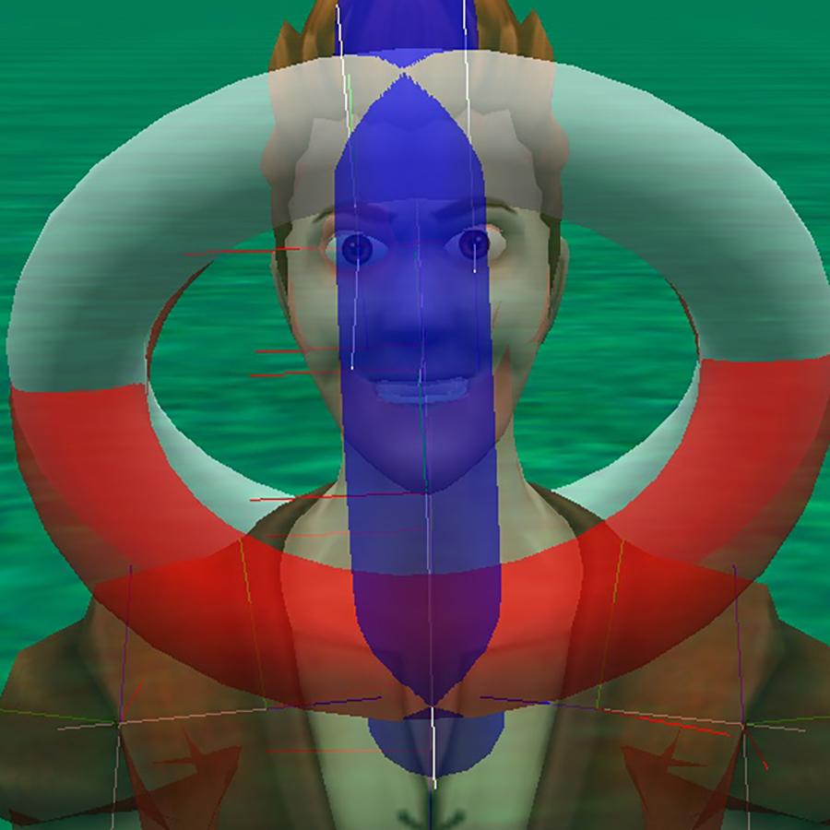

Description: The mouth joint controls the jaw of the character. In alice the mouth is set up to pivot open and closed. The sims characters are set up differently and do not support some movement of the jaw.

Location: Centered in the mouth.

Orientation: The mouth joint generally points forward from the face and slightly down with up pointing towards the top of the head and slightly angled forward.

Natural Range Amount: The natural range of motion for opening the mouth will generally not exceed .125. Rotating the jaw while unnatural can be used to have different shaped mouth openings but would be in increments smaller than .125. The Sims characters will not support turning and rolling the joints beyond the basic open and closing with a supported range of .0 to .1.

Common Turns and Rolls:

* Turning forward and backward - This is the most common mouth manipulation. Turning forward will open the mouth and turning backward will close the mouth. For the sims turns of .1 and greater will open the mouth the same amount and values of .5 and higher will open and then close the mouth. Turns of Alice models will allow the mouth to rotate all the way around.
* Turn right and left - Turning right and left for Alice models will rotate the jaw towards the ears. Sims characters will not process these turns.
* Rolling right and left - Will spin the jaw around the tongue. Sims models will not process these rolls.

#### Eyes

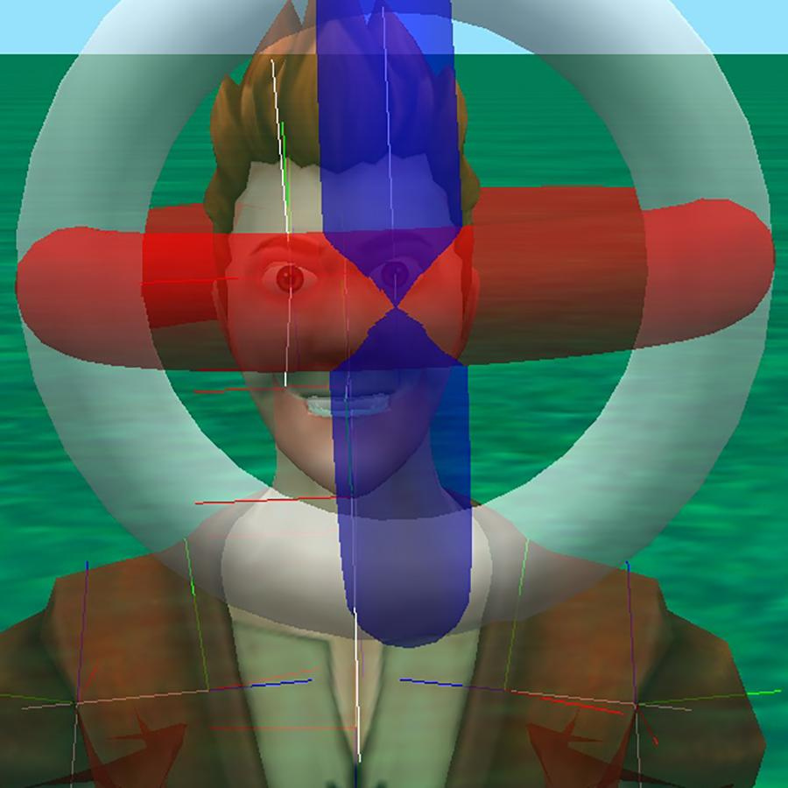

Description: These joints control the eyes as visible by the moving of the retina of the eye.

Location: The joint is centered in the eyeball

Orientation: Forward projects straight through the retina and up points out the top of the ehad

Natural Range Amount: Any turn of more than .125 will cause the retina to go out of view.

Common Turns and Rolls:

* Turn right and left - Will turn the eye from side to side. A right turn will turn the eye to the right and left will turn the eye to the left.
* Turning forward and backward - Will turn the eyes up and down. Forward will have the eye look down and backward will have the eye look up.
* Rolling right and left - Rolling the eye will spin the eye around the retina but will have not visible effect since the retina and eye are a circle. It will change the direction of forward and back turns. * some models the retina may not be completely centered so may have a visible effect.

#### Eyelids

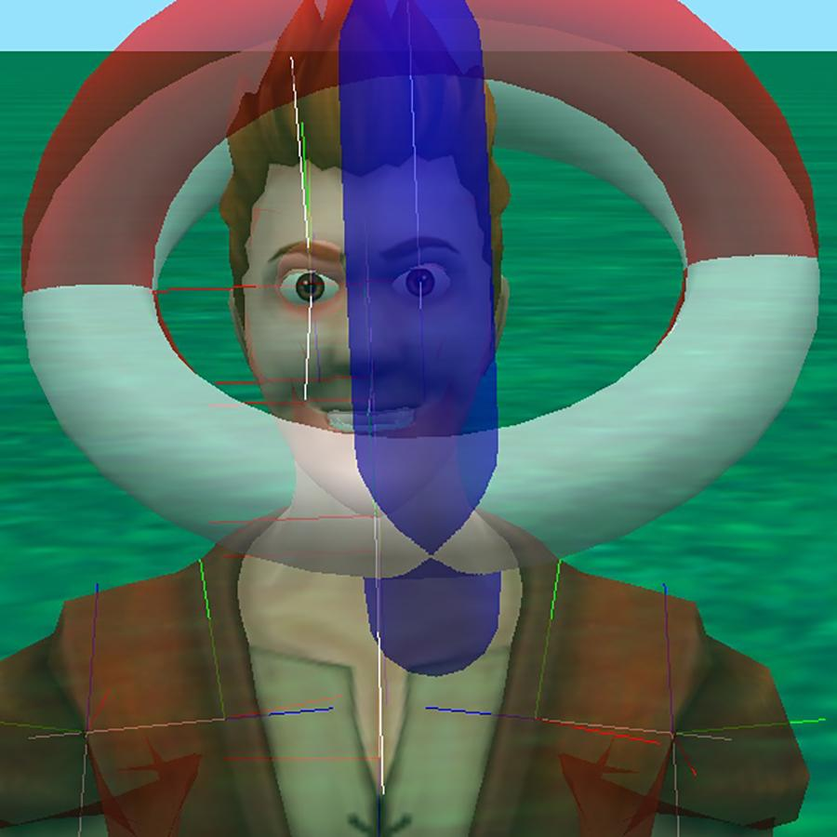

Description: The eyelid opens and closes the eye by turning a sphere that has the eyelid on it. Our models only have a top eyelid that closes down. The sims will only allow you to open and close the eyelid by turning it forward and backward. Alice models will allow you to continue past a closed eyelid have the eyelid then continue around the eye.

Location: The joint is located directly in the center of the eye

Orientation: The eyelid is oriented forward from the eye and up to the top of the head

Natural Range Amount: For both Alice and the sims a .125 will achieve a closed eye. Anything beyond will not change anything on the sims and on Alice models may have you cause they eyelid to continue around the eye going from a top eyelid to a bottom eyelid. The sims characters will close their eyelid and then reopen them on values of .5 and above.

Common Turns and Rolls:

* Turning forward and backward - This is the primary direction for the eyelids. Forward will close the eyelid and backward will open it back up.
* Turn right and left - You can change the orientation of the eyelid using turn left and right but it is not designed to do so and may have odd outcomes. Sims characters will not respond to this input
* Rolling right and left - You can change the orientation of the eyelid using roll right and left but it is not designed to do so and may have odd outcomes. Sims characters will not respond to this input

### Arm Branches (each arm separately)

#### Clavicle Joint

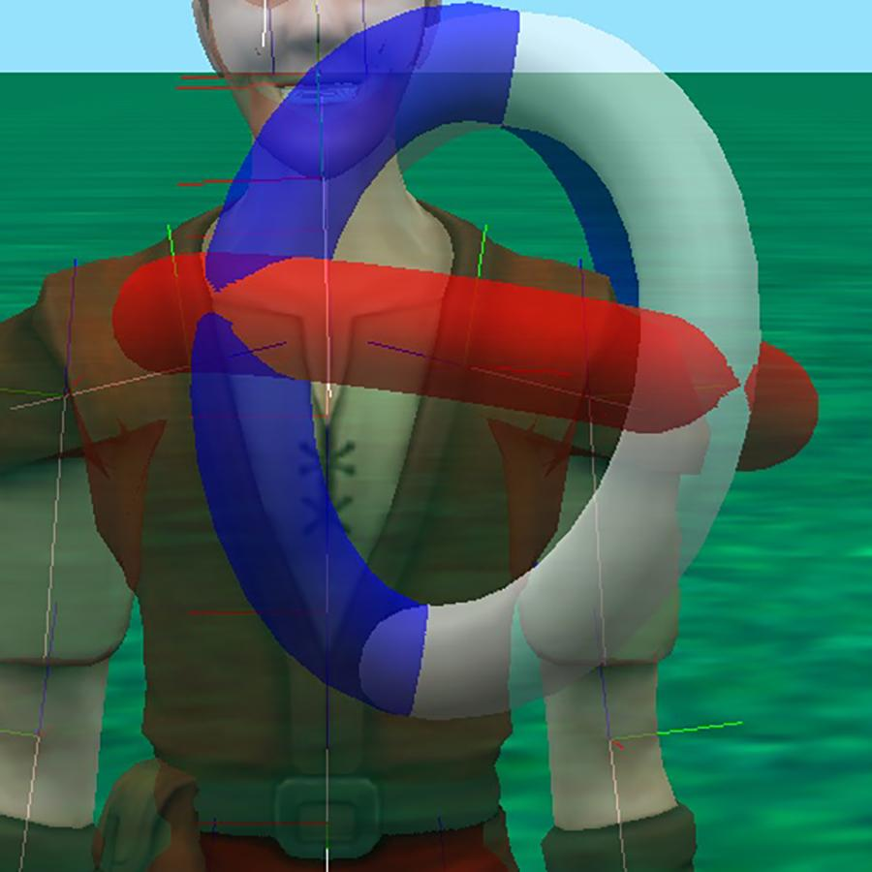

Description: This is a joint that is used to bring the shoulder forward and backward and is generally only used on more nuanced animations. Rotating the clavicle will move all of the arm joints as well as some of the chest.

Location: This joint is located between the upper spine and the shoulder.

Orientation: This joint points forward from the spine upper joint towards the shoulder joint with up oriented to match up for the character.

Natural Range Amount: This joint is usually only manipulated with very small sub .125 movements.

Common Turns and Rolls:

* Turn right and left - will turn the shoulder in towards the chest or backward. The right and left clavicle mirror each other so a left turn for the left clavicle will turn it into the body and a right turn for the right clavicle will achieve the same inward movement.
* Turning forward and backward - will turn the clavicle up and down. This will achieve a dropping or raising (shrugging) of the shoulder along the the axis of the body. Up will shrug the shoulder up and down will drop the shoulder.
* Rolling right and left - will rotate the clavicle around the shoulder line of the character. This will rotate the shoulder and arm forward (raising arm in front of the body) or back (raising the arm behind the body). The right and left clavicle mirror each other so a left roll for the left clavicle will turn the shoulder and arm forward in front of the body and a right roll for the right clavicle will achieve the same forward movement.

#### Shoulder Joint

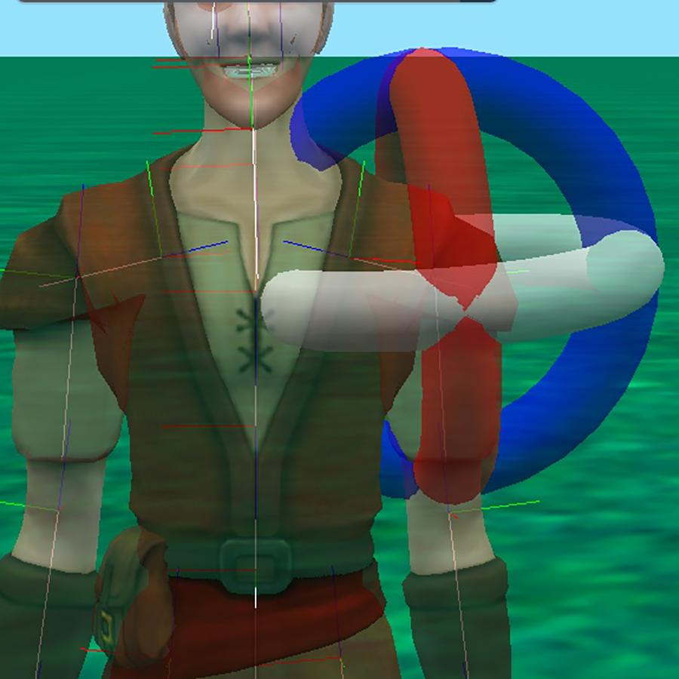

Description: This joint is the mirror to the human shoulder and controls the movement of the whole arm. The orientation of this joint makes the turns and rolls a little different then the intuitive directions relative to the body orientation.

Location: The shoulder joint is centered in the shoulder of the character.

Orientation: The shoulder joint is oriented with forward pointing towards the elbow joint and up pointing out from the body. Since they are mirrored certain turns and rolls will be opposite for each shoulder to affect the same movement relative to the body.

Natural Range Amount: The shoulder will have larger range of motion than most joints with some being able to rotate as far as .5 rotation. Due to the orientation certain turns and rolls will bring the arm through the body.

Common Turns and Rolls:

* Turn right and left - rotates the shoulder around the axis that runs across the body (through the two shoulders). This will achieve the natural arm swing forward and backward. The joints mirror each other so a left turn for the right shoulder will swing the arm in front of the body while a right turn for the left shoulder will achieve the same forward swing.
* Turning forward and backward - rotates the shoulder around the axis that runs forward and backward through the character. Because the up orientation is pointing away from the body a backward rotation will raise the arm away from the side of the body and a forward rotation will rotate the arm in towards the side of the body. This will be the same for both shoulders in their respective directions relative to the body.
* Rolling right and left - rotates the shoulder around the axis that runs from the shoulder to the elbow. This will roll the arm changing the orientation of the elbow. The joints mirror each other so a roll left for the left shoulder will turn the elbow in towards the body while a right turn for the right shoulder will achieve the same elbow turn.

#### Elbow Joint

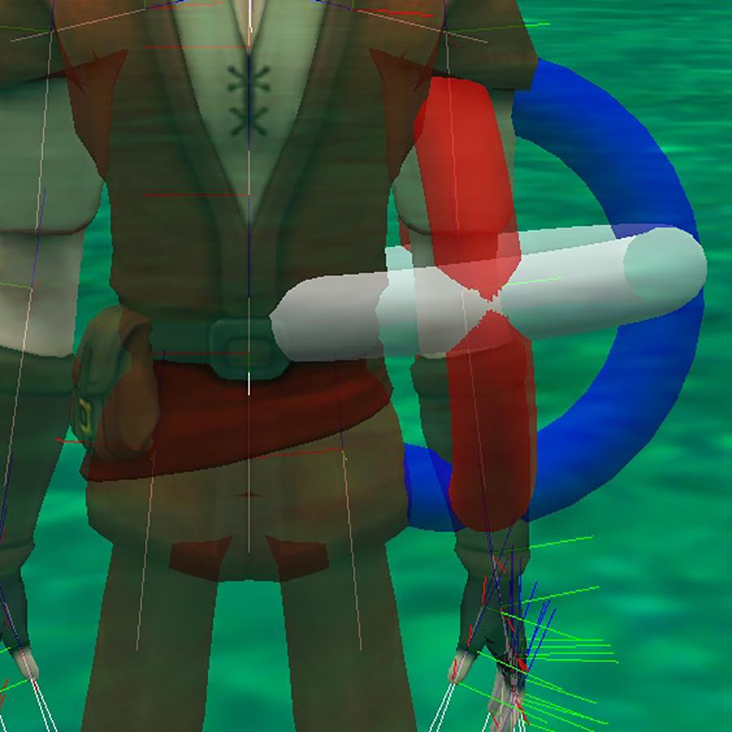

Description: This joint replicates the elbow joint. It is used to bend the elbow, turn the elbow, and roll the forearm.

Location: The joint is centered at the elbow of the character.

Orientation: The joint is oriented to point forwards towards the wrist and with up aligning with up from the back of the hand.

Natural Range Amount: The elbow joint turns and rolls differently for each direction. The elbow bends up to .35 in toward the arm but will not extend the other direction. It can turn about .25 in either direction. It rolls the forearm up to .5 to turn the hand over.

Common Turns and Rolls:

* Turn right and left - Will bend the elbow joint as you would bend your elbow in to close the arm and back to straighten or extend the elbow. Since the joints are mirrored turning the right elbow left will bend the elbow in and turning it right will straighten it back out or overextend it while the opposite turns will have the same effect for the left elbow.
* Turning forward and backward - Rotates the elbow without bending it. A forward turn will rotate the forearm in towards the chest while a backward turn will rotate the forearm away from the body.
* Rolling right and left - Rolling the elbow will rotate the forearm. Rolling the elbow right will turn the wrist and hand clockwise while turning left will roll the wrist and hand counterclockwise.

#### Wrist Joint

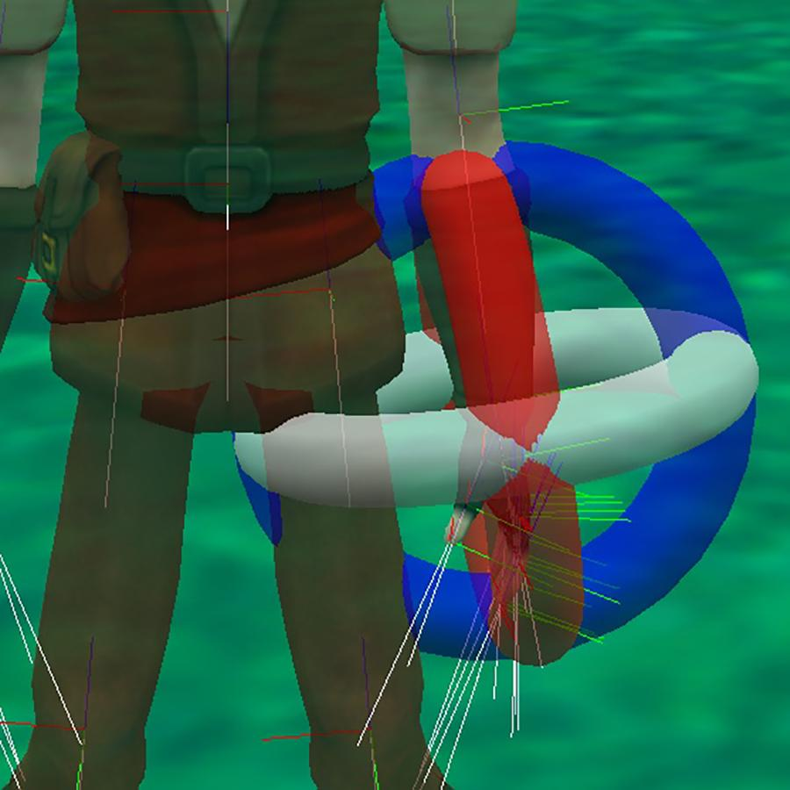

Description: The wrist joint allows you to turn, bend, and roll the hand.

Location: The joint is located right at the base of the hand.

Orientation: Forward points out through the fingers and up points out from the top of the hand.

Natural Range Amount: Each turn and roll has a different range. Bending your wrist can naturally go to around .25, waving or turning your wrist from side to side your wrist generally does not exceed .125, and rolling your wrist to turn your hand over would not exceed .5.

Common Turns and Rolls:

* Turn right and left - Will rotate the hand in the same position similar to a waving motion. A left turn of the wrist will rotate the hand to the left and a right turn of the wrist will rotate the hand to the right. Since the hands are mirrored a left turn for the right hand will turn the hand in the direction of the thumb and a left turn for the left hand will turn the hand in the direction of the pinkie finger.
* Turning forward and backward - Bends the wrist bringing the palm in towards the arm or away. A forward turn of the wrist will bend the hand in the direction of the palm while a backward turn of the writs will bend the hand back in the direction of the back of the hand.
* Rolling right and left - Rolling the wrist will rotate the hand. Rolling the wrist right will turn the hand clockwise while turning left will roll the hand counterclockwise.

#### Hand Joint

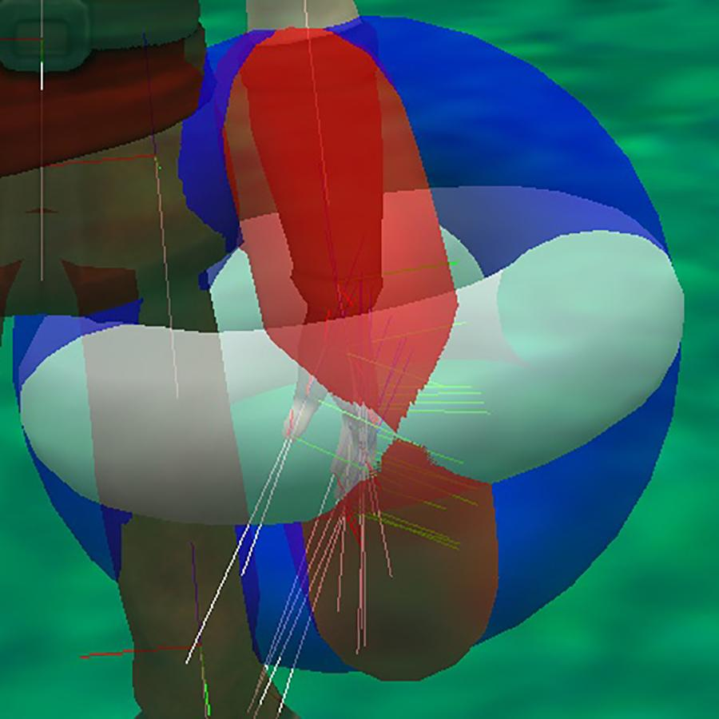

Description: The hand joint is mostly used for a marker joint for things like move to hand joint to help have characters properly hold objects. It can be used to slightly cup the hand or exaggerate movements.

Location: In the center of the hand

Orientation: Forward points out through the fingers and up points out from the top of the hand.

Natural Range Amount: Very small amounts. Generally only used to bend the hand to help close the hand into a fist.

Common Turns and Rolls: The movements mirror those of the wrist found above.

### Upper Body Core Joints (Spine)

#### Spine Upper, Spine Middle, and Spine Upper

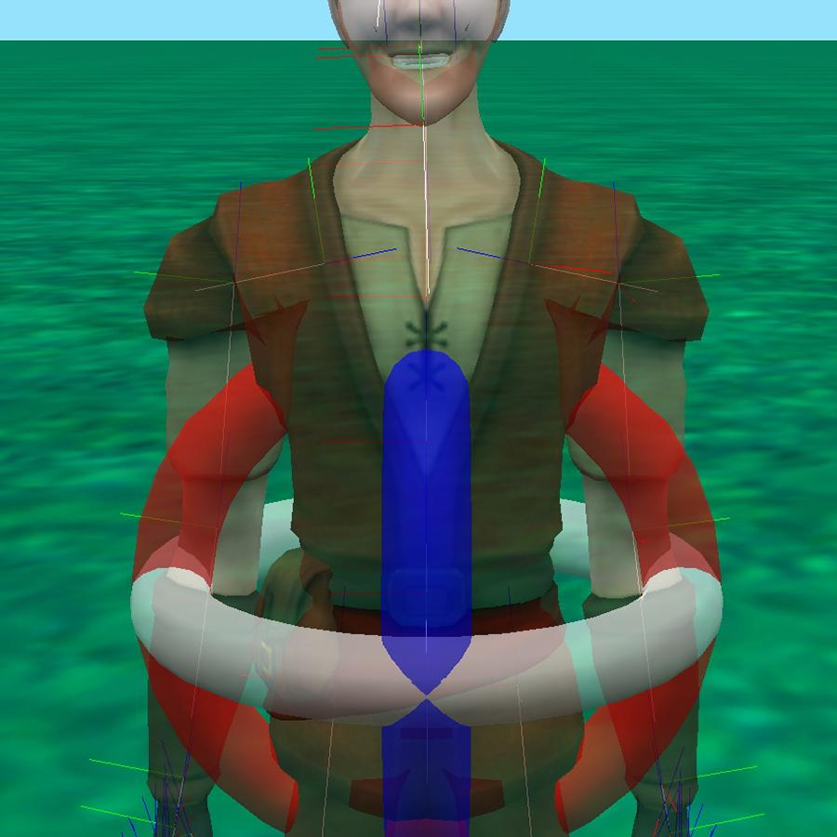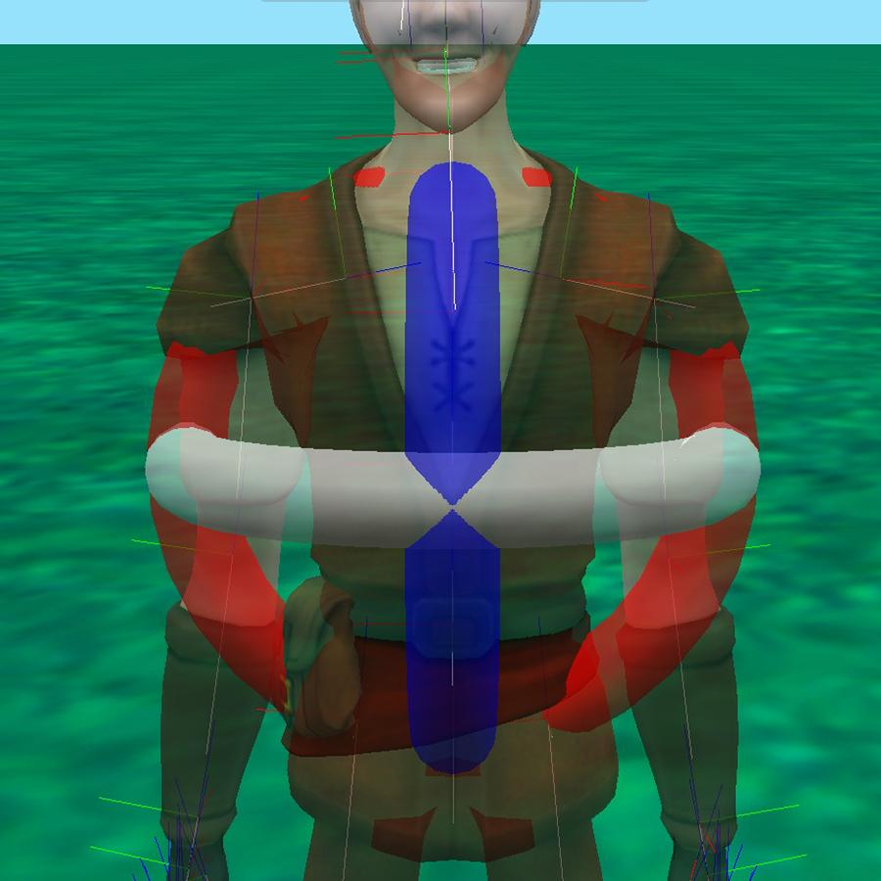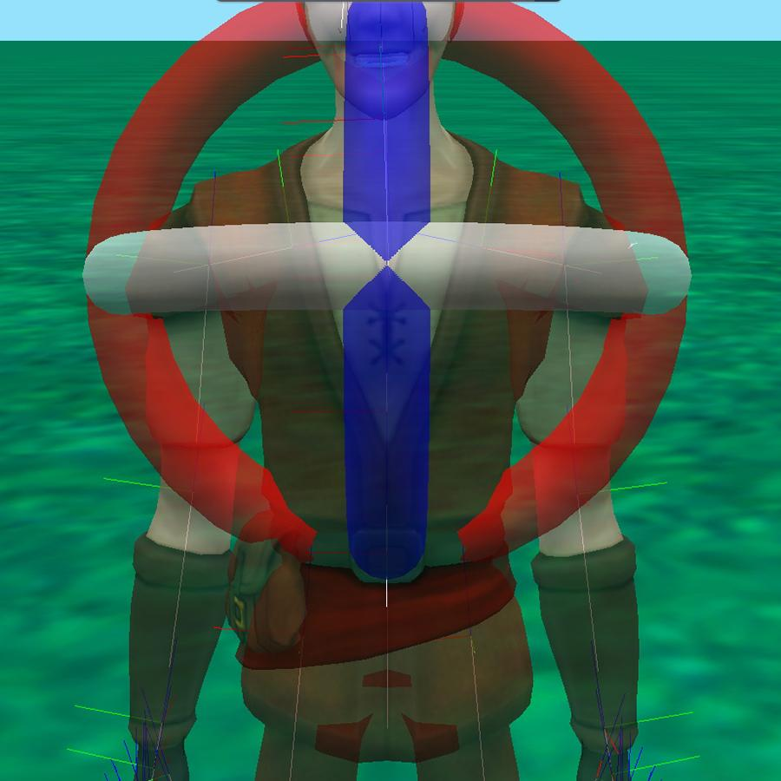

Description: There are 3 joints for the spine. Starting with the lower spine at the characters lower back and progressing up the back of the character: base, middle, and upper respectively. The base spine will move the whole upper body of the character and is the lowest joint that will impact the upper body.

Locations: The base spine is generally located between the hips and relatively close to the pelvis. The spine middle is located center mass of the upper body. The spine upper is usually located between the shoulders.

Orientation: Each joint points (forward) towards the next joint in the back with the upper joint pointing to the neck. All of the spine joints are oriented so that up is pointing out of the back of the character. Imagine the character laying on it’s stomach with forward pointing out of the top if the characters head and right and left pointing out through the arms.

Natural Range Amount: For most of the spine amounts the natural range would not exceed .25 and would generally be less than .125

Common Turns and Rolls:

* Rolling right and left - will rotate the body around the forward/backward directions (through the center of the spine). This will achieve the natural turning of the body to the right or left. Because of the orientation of forward towards the head and up through the back the body turn will be opposite the selected roll direction. A left roll will turn the characters body to the right and vice versa.
* Turn right and left - will turn the body around the axis of the joint that runs through the front and back of the character. This will achieve the natural leaning to the side. Leaning the body towards the turn direction. A right turn would achieve a right side bend.
* Turning forward and backward - will turn the body around the left/right axis (a line through both sides of the body “bending at the waist”). This will achieve a leaning forward or backward of the body matching the direction of the turn. A forward turn will bend the character forward towards its toes.

### Lower Body Core

#### Pelvis

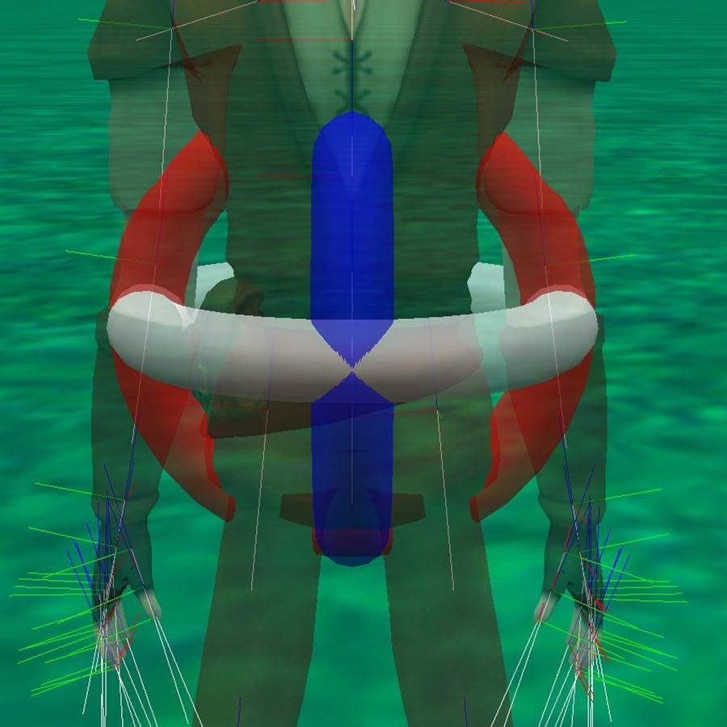

Description: The pelvis is the primary joint for whole lower body. It begins the hierarchy of joints that control the lower half of the character. The pelvis is the only joint that will move the entirety of the base of the character.

Location: Centered between the hips and slightly above, think of it as located at the waist. Almost mirrored with the location of the spine base.

Orientation: The pelvis is the first joint that flips the base orientation to the opposite of the upper body core and instead has forward pointing towards the hip and on down to the feet. The up direction is also switched to point out through the front of the character instead of the through the back.

Natural Range Amount: Generally you would not bend at the waist more than .25 in any direction.

Common Turns and Rolls:

* Turn right and left - Turning the pelvis left and right turns will swing the whole lower body out to the sides of the character. A left turn will swing the lower body out to the left of the character.
* Turning forward and backward - Turning the pelvis forward and backwards sings the whole body to the front and back of the character. Because the up orientation of the lower body goes the front of the character a forward turn will swing the lower body behind the character and a backward turn will swing the lower body in front of the character
* Rolling right and left - will twist the waist of the character around the center of the body. A left turn will twist the waist and the whole lower body to the left and a right roll will twist the waist and whole lower body to the right.

### Leg Branches (each leg separartely)

#### Hip

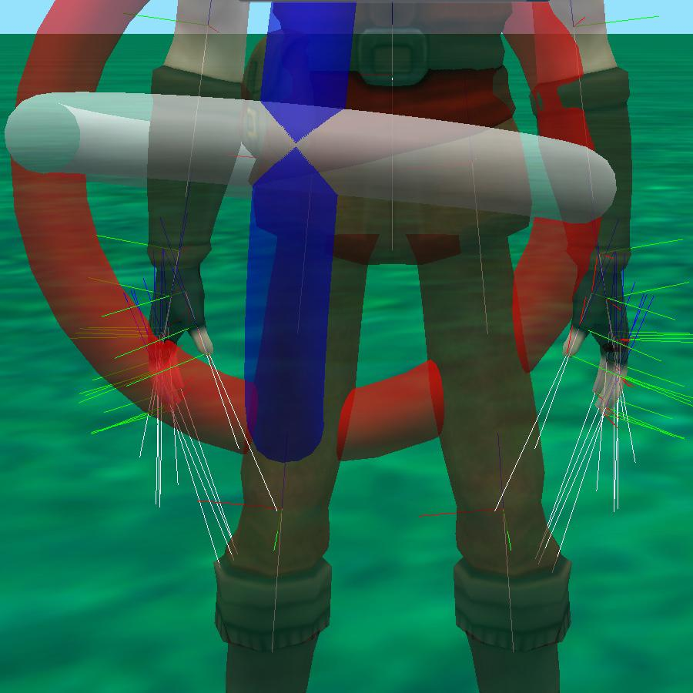

Description: The hips are the first joint of each of the leg branches. The hip will move all of the leg joints.

Location: The hip joints are located just below the waist with each joint centering over the leg it controls.

Orientation: The hip joint points forward towards the knee with up projecting out the front of the character.

Natural Range Amount: The hip generally doesn’t move any more than .25 in any direction. Movements that swing the leg away from the body or forward may have more range than those that swing the leg behind the character or in towards the body.

Common Turns and Rolls:

* Turn right and left - Turn right and left will swing the leg to the right or left of the character in the direction chosen. A right turn for the right leg will swing it out to the side of the body. A left turn can be used to bring the right leg back to the body or swing across the body (slightly unnatural).
* Turning forward and backward - Turning the hip forward and backward is the natural forward and backward swing of the leg. Because of the orientation of the joint the direction may be opposite the intuitive direction relative to the character. A forward swing will rotate the leg towards the back for the character while a backward turn will bring the leg forward in front of the character.
* Rolling right and left - Rolling the hip will turn the leg around the center of the leg up and down. A right turn will rotate the leg clockwise while a left turn will rotate the leg counterclockwise. This will be visible by the foot rotating to match the rotation.

#### Knee

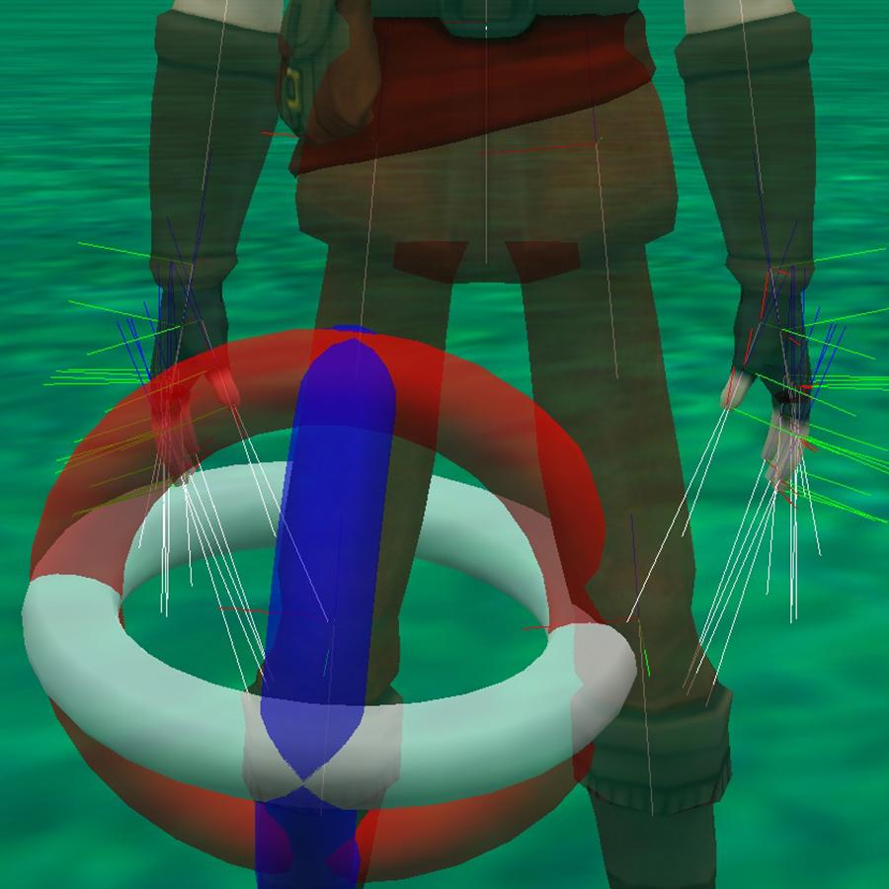

Description: The knee joint is a match to a human knee. Generally you would only manipulate the knee to bend it as the other manipulations are unnatural for a human (but may be possible for other life forms)

Location: The knee is located right in the center of the characters knee.

Orientation: The knee points forward to the ankle and up through the knee cap.

Natural Range Amount: The knee generally only bends and usually not more than .25-.4 of a turn and then back to straight.

Common Turns and Rolls:

* Turn right and left - This will swing the knee to the left and right (very unnatural). Usually motions like this are achieved using the hip if adhering to natural joint manipulation and to keep the knee bend aligned with the ankle and foot.
* Turning forward and backward - This will bend the knee in the natural way. Because of the joint orientation the turn direction may be counter to expected behavior with a forward turn bending the knee from straight to a natural bend behind the leg and a backward turn bending it back to straight or beyond if starting from a straightened position.
* Rolling right and left - Rolling the knee will rotate the ankle and foot joints in the corresponding direction. A right roll will turn them clockwise and a left counterclockwise. As the knee generally stays in the alignment with the ankle and foot these changes are usually done using the hip joint.

#### Ankle

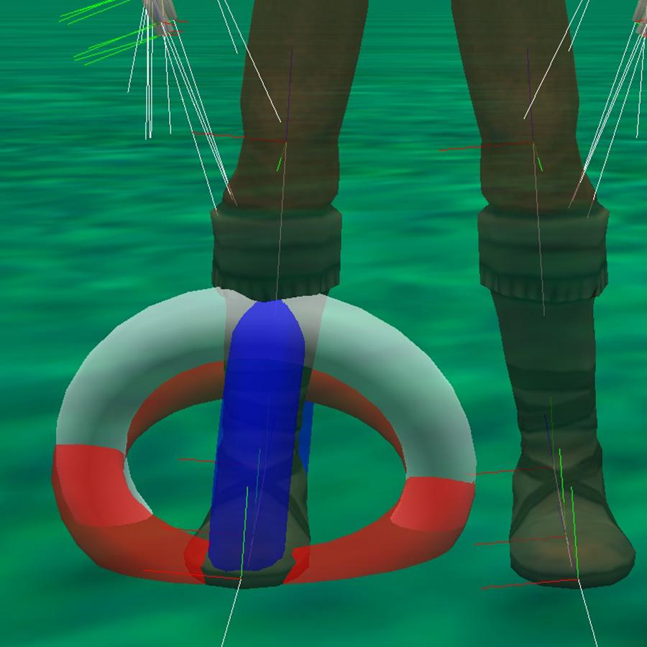

Description: The ankle correlates to the your ankle joint and is used to manipulate the whole foot.

Location: Centered in the ankle of the character

Orientation: The ankle joint points to the foot joint that is found in the center of the foot. This will lead to the forward direction pointing to the front of the character but possible on a slight down slope. The up orientation will point up relative to the top of the foot.

Natural Range Amount: The ankle has the ability to rotate and turn in all directions but usually has a much smaller range when turning rolling or turning (less than .125) than when bending (.125).

Common Turns and Rolls:

* Turn right and left - Will rotate the ankle keeping the foot flat. A left turn will rotate the foot counterclockwise and a right turn will rotate the foot clockwise.
* Turning forward and backward - This is the most common manipulation of the ankle and will bend the ankle to point the toes (forward) or bring the toes towards the shin (backward)
* Rolling right and left - This will rotate the foot around the axis running from heel to toe. This is not a direction most people can control but is one that allows the foot to lay flat when the leg and body move in certain directions.

#### Foot

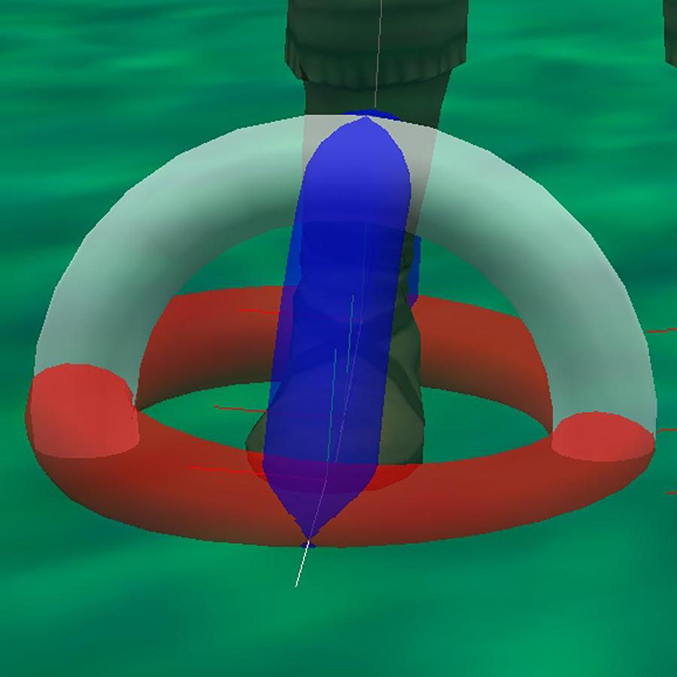

Description: The foot joint is not one that correlates to a specific joint in human anatomy. Most of the manipulations of the foot joint will be unnatural in human anatomy. It is more often used to move objects to the foot. (like a soccer ball). The location is not exact but it could also be used to approximate the bending of the toes to replicate tip toes or the bending of the toes when walking.

Location: The foot joint is located directly in the middle of the foot.

Orientation: The foot joint points forward towards the toes with up projecting out of the top of the foot.

Natural Range Amount: There are not many natural distoritions of the foot. A range of .125 may replicate the bending of the toes when walking or standing on your toes.

Common Turns and Rolls:

* Turn right and left - Will bend the foot right or left unnaturally.
* Turning forward and backward - Will bend the toes up and down replicating the natural bend of the toes.
* Rolling right and left - will twist the foot around the heel to toe axis.