Alice_Logo_horizontal-02.jpgExercise

Hour of Code/ Event Workshop Guide

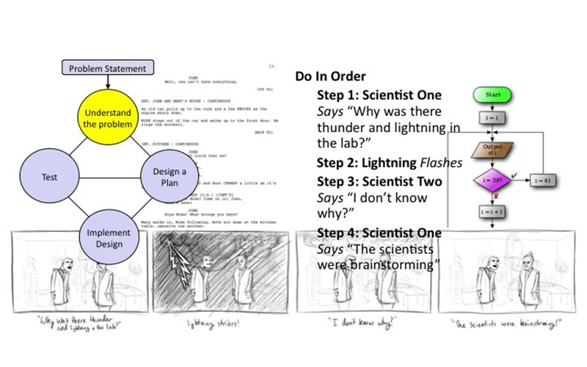

# Introduction – The Animation Design Process

This tutorial exercise provides step-by-step directions for guiding you through designing and implementing a simple animation. Here you will explore the different methods that can be used for each step of the process as you follow along. This will provide an overview of the problem solving process and teach you the basic process to get you started designing implementing and iterating an animation in Alice.

You will need to access other printed materials or have access to the alice.org website to view the How To video content and resources called out within these materials. These materials can be downloaded and printed for offline use from Alice.org

Don’t forget to save your projects frequently.

# Setting Up the Project

For the following steps, you may wish to watch the *How To: Scene Editor Overview* and *How to: Using Camera Markers* videos or check the Quick Reference Guide associated with the videos.

1. Start Alice
2. Select a template from the Blank Slates section of the **Select Template Dialog** box
3. Save the project right away so that your work will be safe and the backup saves will begin
4. Click on the *Setup Scene* button to go to the **Scene Editor** of Alice
5. Create a startingCamera camera marker,
   1. Scroll to the bottom of the object properties panel and click the arrow to expand the Camera Markers controls
   2. Select Add Camera Marker…
   3. Name the Camera Marker startingCameraLocation or similar using camelCase rules

# Building Your Scene

For the following steps, you may wish to watch the *How To: Adding Objects, How To:* *Positioning Objects, How To: Rotating Objects, How To: Manipulating Object Joints, How To:* *Moving The Camera* or check the Quick Reference Guide associated with the videos.

1. Browse the gallery and start to think about:
   1. Who are the characters in my story?
   2. Where does my story take place?
   3. What happens in my story?
2. Add objects to your scene:
   1. Characters (The Who)
   2. Props that might inform the action or narrative (The What)
   3. Scenery (The where)
3. Arrange the scene and pose characters for the starting positions of your animation
   1. Remember that if you want to have them enter the scene later they still need to be added but can be put off screen or set to 0 opacity
4. Save your project

# Crafting a Story (Brainstorming)

First you will need to decide what story you are telling. Use the scene you built as a jumping off point but you can always go back and change it just remember what you saw in the gallery. Here is a list of some great resources for using as a starting point to get the creative juices flowing:

- Characters singing your favorite song or animating a music video

- Characters telling jokes (ex. A knock knock joke)

- Your favorite internet meme

- Funny or sentimental eCards

- Existing comics strips and cartoons

- Even a serious conversation or event

1. Find a source for your story or come up with a story idea of your own.
2. Pitch your idea to a friend or someone near you or share it with the group if time permits. Getting feedback may help give you good ideas for how to expand your story.

# Crafting a Story (Write a Script and/or Draw a Storyboard)

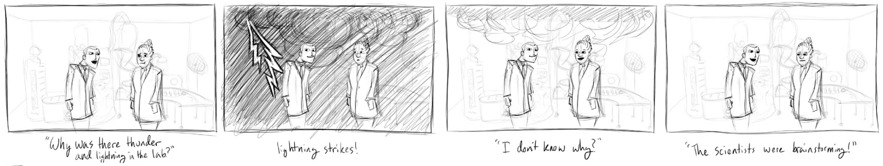

1. Create a script for your story or/
   1. Be sure to describe the scenery
   2. Detail out the actions and dialogue for your story
2. Draw a storyboard of your story
   1. Create frames that highlight key actions in your story
   2. Add comments to add detail if necessary
3. Share your script or storyboard with a friend or someone near you or share it with the group if time permits. This is another great time to share your script or storyboard with a friend for creative feedback and ideas. It is easier to make changes in the design phase than after you have spent a lot of time programming.

# Planning a Program

Next you will start to outline the specifics of your program through a textual algorithm design, a flowchart, or both.

**Do In Order**

**Scientist One** *Says* “Why was there thunder and lightning in the lab?”

**Do Together**

**Fog** *Fills* room

**Lightning** **Object** *Flashes*

**Lights** *flicker*

Thunder sound *plays*

**Scientist Two** *Says* “I don’t know why?”

**Scientist One** *Says* “The scientists were brainstorming”

**Camera** *Zooms in*

**Scientist Two** *Says “HAHAHAHAHAH”*

1. Write out a step-by-step set of directions focusing on highlighting the objects or characters in the story and the actions or events that take place
   1. Focus on highlighting the objects or characters in the story and the actions or events that take place
   2. Be sure to note what happens in order and what happens at the same time
   3. Be as detailed as you need to be clear about what you need to program

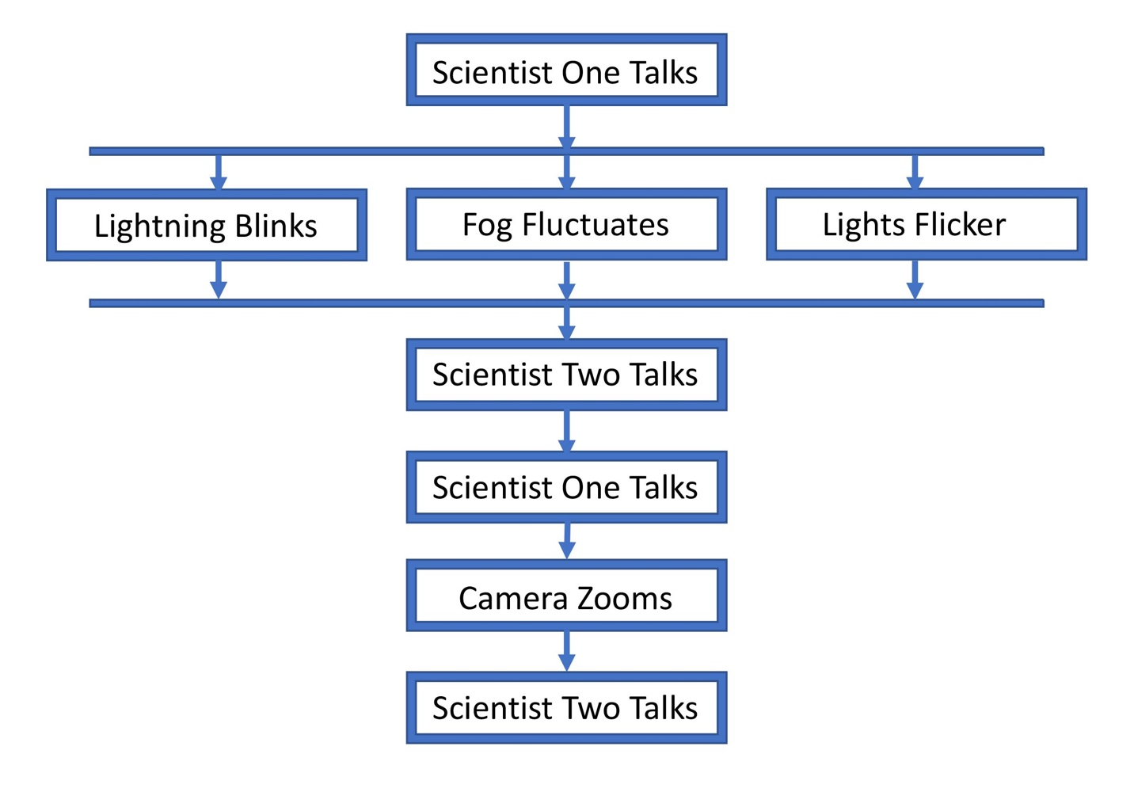

1. Diagram a flowchart of the events of your story giving each action a separate box
   1. Connect the events or actions together in the order they occur with arrows if you need to represent multiple events happening at the same time by branching your arrows and bringing them back together
   2. You can expand each box and make a separate diagram to represent the action or event if it needs more detail for planning your program

# Coding an Animation (Use Comments to Plan Your Program)

Before starting to build your program, use comments from the control panel to outline what you want to create. For the following steps, you may wish to watch the *How To* videos or check the Quick Reference Guides for the *Code Editor Overview* video.

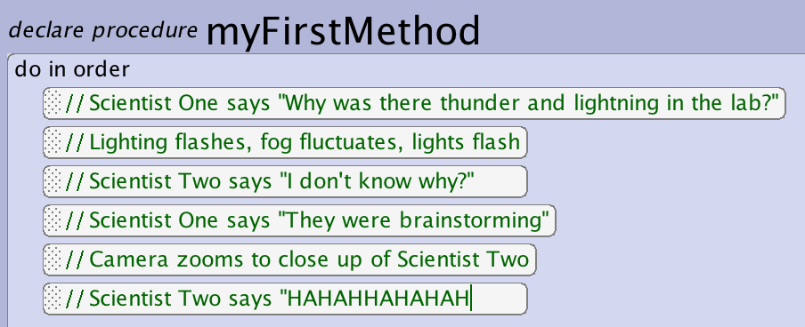

1. Navigate to the Code Editor
2. Drag comment blocks from the control panel into myFirstMethod
3. Outline your program based on your algorithm design creating separate comment blocks for each object and action to allow you to insert the code statements in between your comment blocks
4. Save the project

# Coding an Animation

To program the actions and events that you have outline in your comments, use the Code Editor to add code statements to myFirstMethod. For the following steps, you may wish to watch the *How To* videos or check the Quick Reference Guides for the *Code Editor Overview* video and related Code Editor *How To* video content.

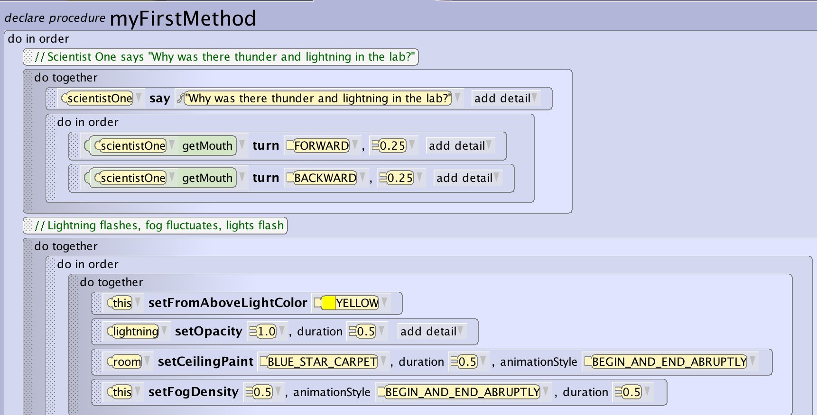

1. Build your program using the Code Editor
   1. Insert code statements to build the actions that are outlined by your comments
   2. Add, move, separate and remove comments, as needed, to enable you to build and document your animation
   3. Don’t forget you can incrementally build your full story by working through small parts of the animation
   4. Experiment with nesting *do together* and *do in orders* to get a set of movements that you like.
   5. If you have time try animating the camera, using scene effects or adding audio to your world.
2. Save the project

# Run Your Animation

Remember you can run and test your animation as often as you like. Skip to this step whenever you have built enough of your program that you want to see if it is behaving as desired.

1. Save the project. It’s a good idea to save the program before running in case a fatal error occurs. Alice is designed to avoid this but this is also a point where Alice can cause computers to freeze so it is better to be safe than sorry.
2. Run your animation and see if there are any problems with the output
   1. You can disable sections of the code to only execute parts of the animation by right clicking and enabling and disabling.
   2. You can also fast forward to areas of your code. This may be necessary if you are disabling code because objects and characters are not in the right place to execute later animations.

# Iterate Until You Are Happy

The design process can be repeated as many times as you want until you are happy with your program. You can iterate through small components of the animation, adding more as you go and troubleshooting existing designs. Continue this process of defining the problem, thinking through the design solution, implementing your design, and then testing until you have completed your animation and are happy with the results.

1. Repeat previous steps until happy!
2. Share your world with other around you or if possible project it for everyone to enjoy. Don’t forget to give your animation a title and think about any surrounding information for a setup or prequel.