Assessment

The Alice Scene Editor

# Provide Definitions of the Following

# **Programming Terms**

Virtual World

Scene

Class

Object

Class Hierarchy

# **Alice Terms**

Scene Editor

Gallery

Properties Panel

Object Tree

Mouse Handles

Camera Controls

Camera Viewpoint Menu

Camera Markers

Pivot Point

One-shots

Joint

Sub-parts

Orientation

# Questions

1. What are the six directions an Alice object can move?
2. What is the difference between an object and a class?
3. What is meant when it is said that an Alice object moves, turns, or rolls according to its own “point of view”?
4. Explain the Alice Gallery hierarchy.
5. Describe the location and purpose of an object’s pivot point.
6. Describe the relationship between an object’s joints and its subparts.
7. Complete the Alice Scene Editor Map (attached).
8. Create a new scene of your own design, or choose one of the scenes described in the Exercise / Projects section of the web site.

# Scene Editor Map

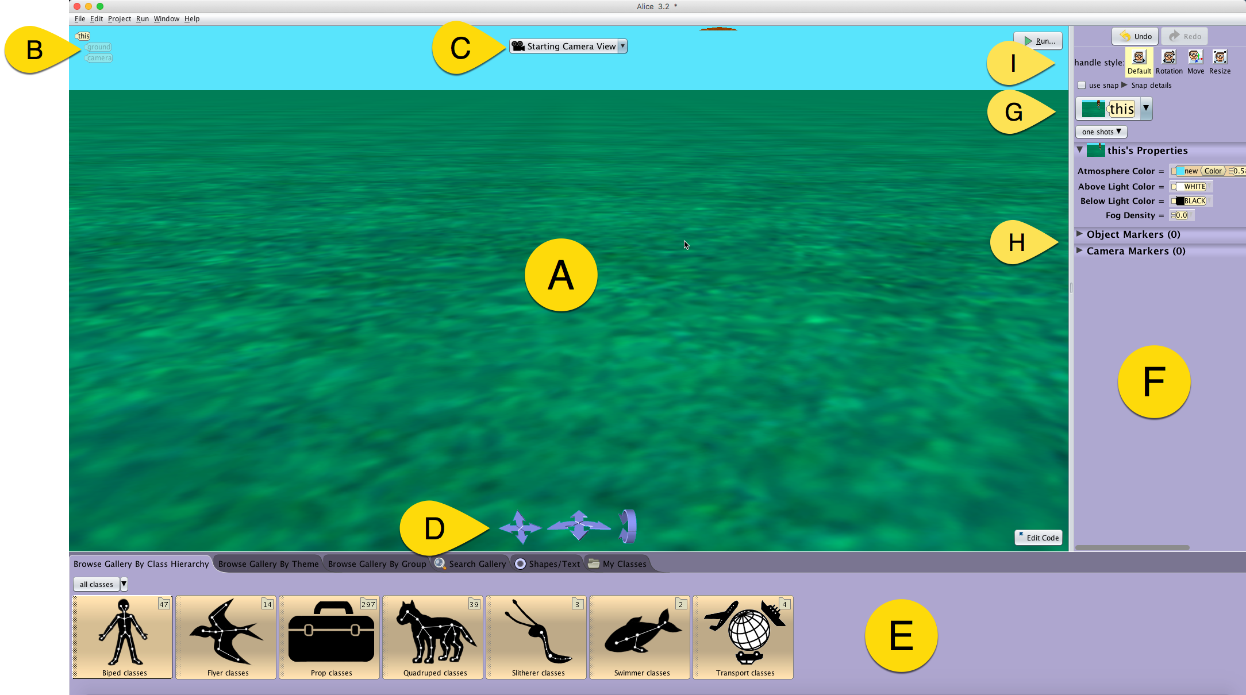

***Place the appropriate letter next to the listed element of the Alice 3 Scene Editor***

|  |  |  |  |  |  |
| --- | --- | --- | --- | --- | --- |
|  | **Camera View Panel** |  | **Properties Panel** |  | **Gallery** |
|  | **Camera Controllers** |  | **Mouse Handles** |  | **Object Tree** |
|  | **Object Menu** |  | **Camera View Menu** |  | **Markers Section** |