Exercise

Tutorial: Scene Building

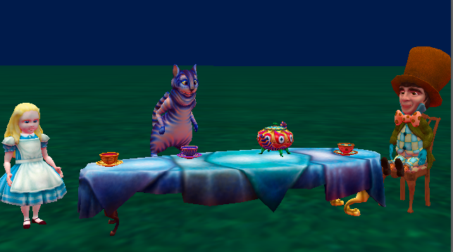

# Introduction – Wonderland Tea Party

This tutorial exercise provides step-by-step directions for building a scene. Here you will explore the different methods that can be used for each skill. This will provide an overview to the Alice Scene Editor and cover the basic skills to get you started.

In this exercise you will construct an Alice in Wonderland tea party similar to what is presented in the image above.

You will need to have access to alice.org to view the *How To* video content. These materials can be downloaded and printed for offline use.

Remember to save your projects frequently.

# Setting Up the Scene

For the following steps, you may wish to watch the *How To: Scene Editor Overview* and *How to: Using Camera Markers* videos or check the Quick Reference Guide associated with the videos.

1. Start Alice
2. Select the ***Wonderland*** template from the Blank Slates section of the **Select Template Dialog** box
3. Save the project right away so that your work will be safe and the backup saves will begin
4. Click on the *Setup Scene* button to go to the **Scene Editor** of Alice
5. Create a startingCamera camera marker,
   1. Scroll to the bottom of the object properties panel and click the arrow to expand the Camera Markers controls
   2. Select Add Camera Marker…
   3. Name the Camera Marker startingCameraLocation or similar using camelCase rules

# Adding Objects

For the following steps, you may wish to watch the *How To: Adding Objects* or check the Quick Reference Guide associated with the video.

1. From the ***Wonderland*** section of the *Browse Gallery by Theme* tab of the Gallery,
   1. Add the **TeaTable by double clicking it and adding it at the center of the world**
   2. Drag **Alice into the scene**
   3. Add the **CheshireCat** using either method
2. Go to the ***Search*** tab of the **Gallery**, and do a search for “chair.” Select a **chair** and add it the scene

# Positioning Objects

For the following steps, refer to the image above, or use your own ideas. You may wish to watch the *How To:* *Positioning Objects* or check the Quick Reference Guide associated with the video.

1. Place **Alice** at one end of the table using the mouse controls
2. Place the **chair** at the other end of the table from Alice. Try using the x, y, z text inputs
3. Using the handle styles or hotkeys, position the **CheshireCat** above the table, as if it is floating in the air

# Orienting Objects

For the following steps, refer to the image above, or use your own ideas. You may wish to watch the *How To: Rotating Objects* or check the Quick Reference Guide associated with the video.

1. Turn Alice to face the table using the rotation handles
2. Turn the chair to face the table using a one shot
3. Save the project

# Using Camera Controls

For the following steps, you may wish to watch *How To:* *Moving The Camera* and *How To: Using Camera Markers* or check the Quick Reference Guides associated with these videos.

1. Use the camera controls to position the camera to a closer / more interesting viewpoint of the scene that still shows all the characters and props
2. (Optional) Set a new camera marker at this position. Test the marker by moving the camera to a different position and then returning to that position

# Aligning Objects

For the following steps, refer to the image above, or use your own ideas. You may wish to watch *How To: Using Camera Views* or check the Quick Reference Guide associated with the video.

1. From the ***tea set*** section of the ***Wonderland*** section of the Gallery, add a **teapot**, a **cup** and **saucer** to the scene
2. Place the **teapot** in the center of the table
3. Place the **saucer** at the other end of the table, from where Alice is standing, then place the **cup** on the saucer. (**Hint**: *Use the one-shot procedure to have the teacup* ***moveAndOrientTo*** *the saucer*)
4. **Optional**: If there is time, add and place a cup and saucer for both Alice and the Cheshire Cat in the scene
5. Move the camera using a camera marker to return it to the starting position and/or use the different camera views to validate your alignments
6. Save the project

# Manipulating Sub Joints

For the following steps, refer to the image above, or use your own ideas. You may wish to watch *How To: Manipulating Object Joints* and *How To: Resizing Objects* or check the Quick Reference Guides associated with the videos.

1. From the ***Wonderland*** section of the *Browse Gallery by Theme* tab of the **Gallery**, add the **MadHatter** to the Scene
2. Sit the **MadHatter** in the chair. Use one-shot procedures for the following:
   1. Select the *rightHip* of the **MadHatter** and turn it **backward** **0.25** revolutions
   2. Select the *leftHip* of the **MadHatter** and turn it **backward** **0.25** revolutions
   3. ***moveAndOrient*** the MadHatter to the chair
   4. **Optional:** You may want to resize the chair
3. Save the project