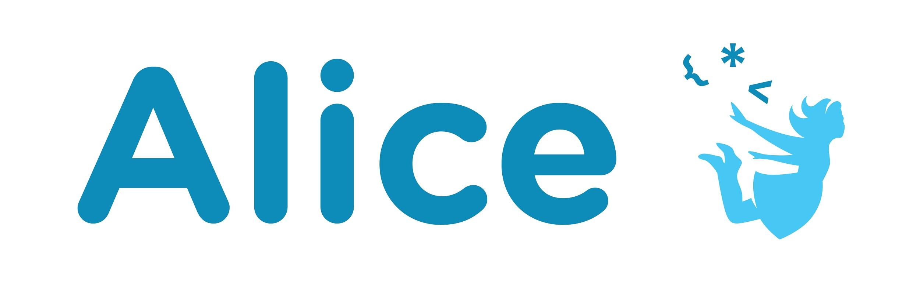Assessment

The Alice Design Process Introduction

# Project Assessment

The primary assessment for this lesson is evaluating the final project. Be sure to have the student submit all created materials with their project including:

* The script or storyboard
* The algorithm design or flowchart
* Set design drawings or summaries (could be marked up script or storyboard)
* The final project file
* Optional - Summary of changes that occurred during implementation

Remember that due to the iterative process it is ok that the final project may look different than the initial design. Ideally they would update the design documents during this process but this is not always to be expected. Be sure to evaluate the use of comments to outline the project and the final alignment of comments within the program. Additionally, depending on the course this lesson is being used in you could also evaluate creativity, complexity, story and more.

You can optionally turn this project into an animation competition or film festival. We use the following rubric for evaluating:

* **Creativity:** How unique is the story that is being told or the approach of the presentation?
* **Visual Presentation:** How immersive is the world that has been created? How complex or impactful is the flow of the visual representation, camera movements, and general composition?
* **Technical Implementation:** How complex is the technical implementation? Does the entry make use of programming concepts to simplify or structure the project? Is the code commented making it easy to understand? Does the entry make use of audio or other features?

# Provide Definitions of the Following

# Design Terms

Design Thinking Set Design

Iterative Design Flow Chart

Script

Storyboard

# Programming Terms

Algorithm

Comments

# Questions

1. What are the benefits planning before starting to program?
2. What are the different steps in design thinking?
3. What is iterative design and why is it useful?