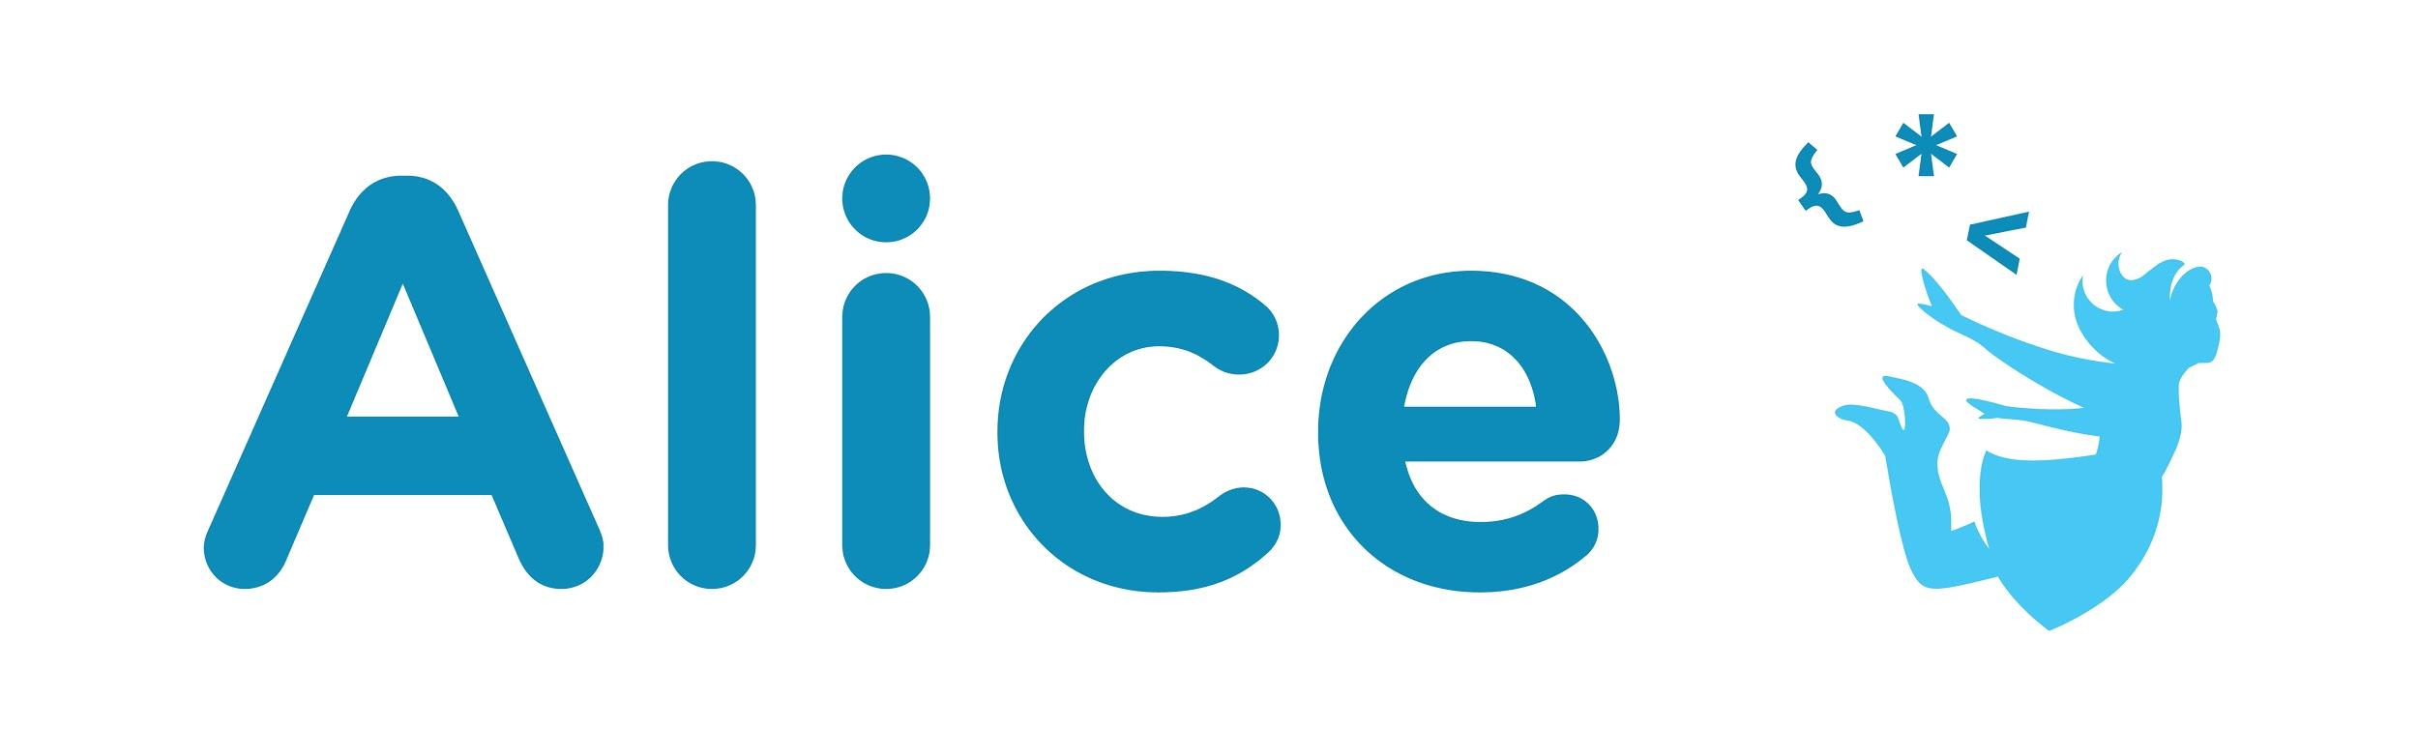Design Process

**Animation Example: Sea Encounter**

# About

This is an example of the design process behind creating an Alice animation. It is meant to serve as an example road map of following the design process outlined in the Design Process Introduction lesson. It is annotated to show some of the design thinking and feedback that went into each step of the process and impacted the final design. At the end of this document you can see a stand alone version of what the design document produced through this process looked like.

# Step 1: Problem Statement

The first step of the design process is to come up with a problem statement. Included in this process for us was a requirement to pitch the concise one sentence problem statement (story concept), a longer story summary pitch, and a title.

The student was challenged with the following design constraints when thinking of their idea:

* Create a world that uses all of the different ways to incorporate audio into an Alice animation : background music, sound effects timed with an animation, and creating and adding custom audio.

### Brainstorming Process

There are a number of ways to begin brainstorming for a new project. For this project the student found a good approach was to start by looking at the existing audio library for inspiration and then scanning the gallery looking for environments or characters that worked well with the available audio.

* Wanted to create a dramatic interaction between shark and a pirate
  + Searching the supplied audio library liked the Pirate background music and shark attack music
  + Liked the existing shark and pirate ship assets in the Alice gallery.
  + Thought a character walking on the ship was a good place to pair audio to an animation
  + Could record audio for the pirate character talking as a custom audio example
* Thought about the JAWS theme with a shark attacking the card, but decided to have a surprise ending with the shark and card as friends.

### Pitch Process

The first pitch process is intended to be a quick way to share the idea and get feedback from others. In this instance we liked the very first idea presented. This could go through multiple iterations with constructive feedback from friends, clients, teachers.

**Problem statement** (High Level Pitch): Create an animation where a shark threatens a pirate but then in a surprise ending they become friends.

**Long Form Pitch:** Our story starts with the playing card pirate aboard his ship. The pirate ship is attacked by a Great White Shark, sending the Playing Card Pirate into the sea. Just as the audience thinks the Playing Card Pirate has reached his demise, the Pirate emerges from the water, riding the Shark over the waves.

### Title

A good title is always nice for framing the project. You can see the ideas pitched and the feedback that was given before settling on the final title.

Brainstormed Title Ideas:

* ~~Card Shark~~- NO- witty, but doesn’t suggest story about the sea
* ~~Shark Attack~~- this gives the story away, and they might be friends at the end
* Sea Encounter- sets scene, provides an element of mystery!
* Captain Card- Like the alliteration; somewhat sets the scene
* ~~On Deck~~- Punny, but no, not clear enough
* ~~Seven of Spades Sails the Seven Seas~~- catchy, but looooooong

Given the Title: Sea Encounter

# Step 2: Understand the Problem

The next step was to think about what this idea would look like. The students was first challenged to answer the following questions to better understand and think about the underlying story.:

**Who:** Pirate (chose the playing card asset because liked the character)

**What:** Comes Face to Face with a Shark whom he befriends

**Where:** At Sea, aboard his pirate ship

**Why:** In order to survive and continue his quest for buried treasure

This process can help flesh out holes in the story and better understand the core components.

### Narrative Development

With the major components decided it was time to move on to the pre production step of creating a script or storyboard.

#### Storyboard

The student first did a very rough storyboard of the animation

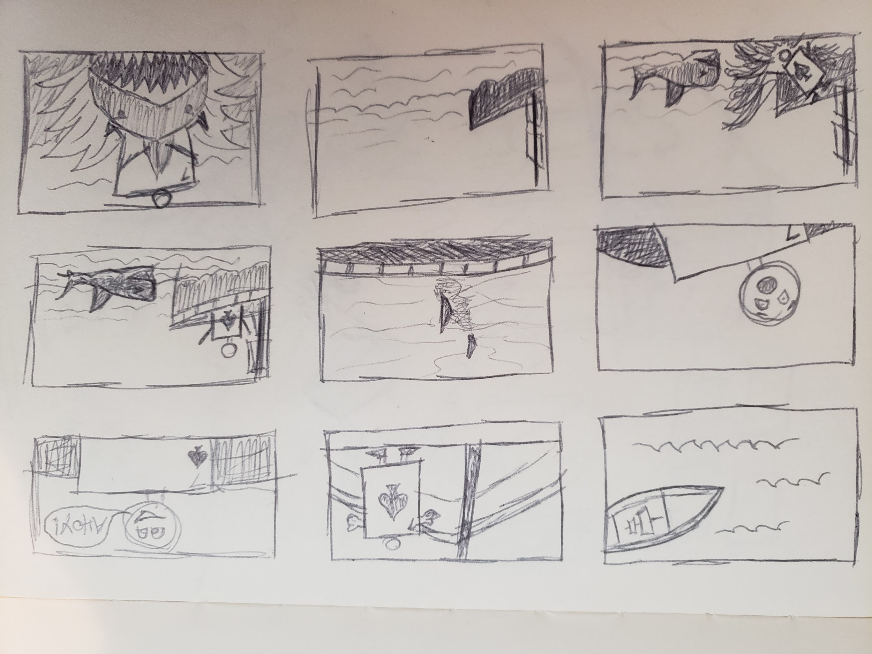

#### Script

Since so much of the action happened between the frames and was done using camera moves and audio cues the student decided to write out a script to make it easier to understand what they were envisioning.

This script is very descriptive with lots of stage directions that are the items in ()

OPENING: CAMERA looking down and filling the frame with blue water. Large SHIP with sails is entering the top of the frame. Wind and water sounds playing. Sea shanty music fades in.

(SHIP sails into the middle of the frame. CAMERA sweeps down to eye level with the ship deck. Water and wind sounds fade out.)

(CARD is in the camera frame and walks toward the camera. Footstep sound effects as he walks. Music continues playing.)

CARD: Ahoy Matey! (To camera. Speech bubble appears on screen with text. Voice recording for audio plays.)

(CARD turns to look over the side of the ship out to sea.)

(CAMERA swings behind CARD and over CARD shoulder toward the sea. Camera pauses.

(Music changes to Jaws-like theme.)

(SHARK swims toward the boat. Only Dorsal fin and tail fin are visible and sticking out of the water.)

(CAMERA zooms in on a shark as it nears the ship.)

(CAMERA turns toward CARD. Music changes to dark and threatening.)

(CAMERA zooms in on the card face.)

CARD (looking shocked): GASP

(CAMERA pans out to show SHARK, and SHIP)

(SHARK forcefully collides with SHIP and rocks SHIP. Collision sound effects.)

(CAMERA pans up to CARD)

(CARD falls overboard. Splash sound effects.)

(CAMERA pans out to show ship and ocean.)

(CARD and SHARK emerge from water and enter the bottom of the frame. CARD is riding the SHARK. Splash sound effects. )

(CARD and SHARK move toward the camera and exit top of frame. Music changes to a more upbeat sound.)

ENDING: SHIP in view. Screen goes black.

### World Design

To start to understand how the narrative would exist in the 3D world the student sketched the layout of the set.

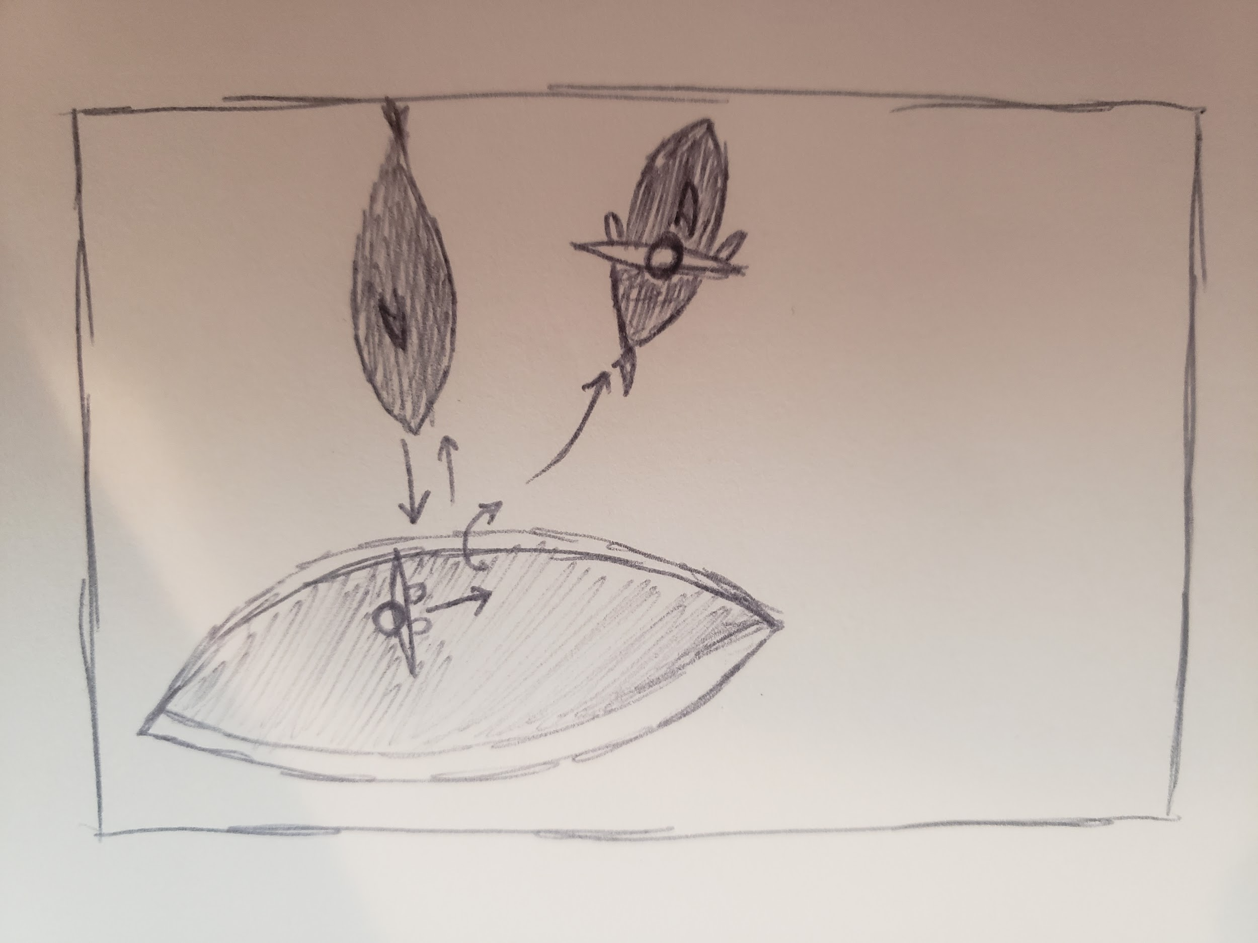

# Step 3: Design the Solution

### Set Design

When the student began looking at the storyboard and the world design they realized that the set design needed to incorporate the camera angles in the storyboard to fully understand the needs for setting up the scene. They expanded the drawing to add these:

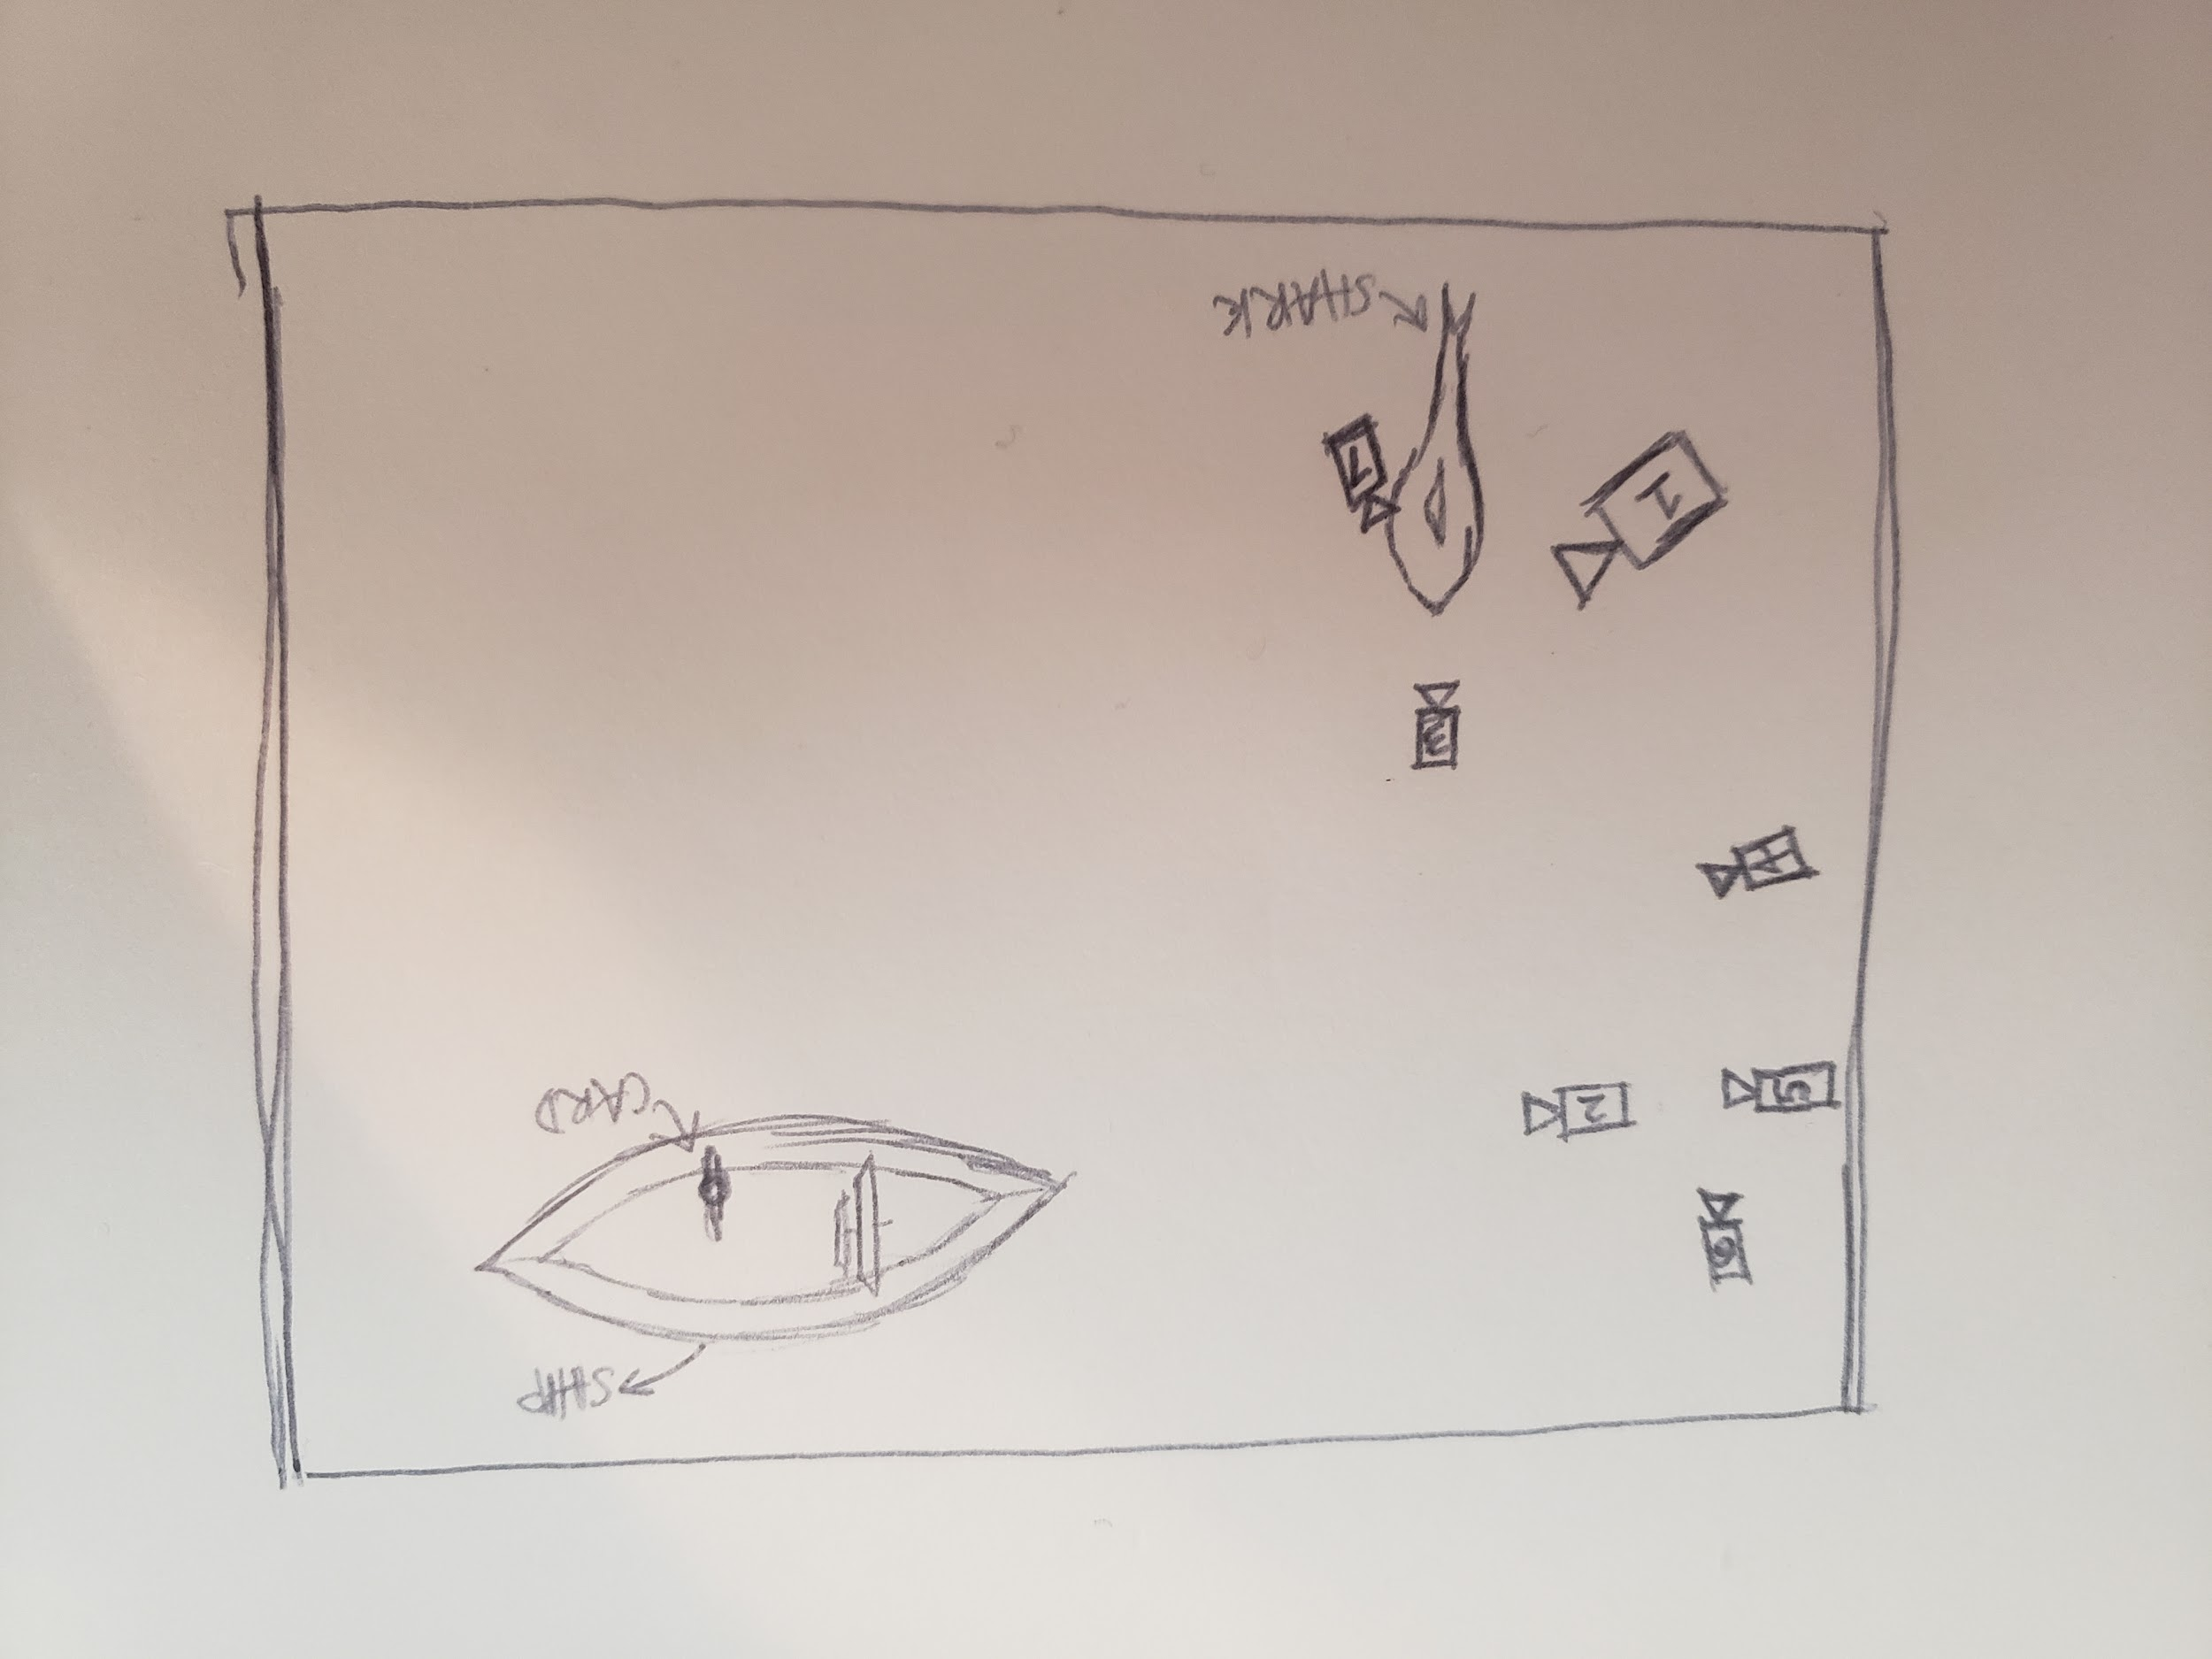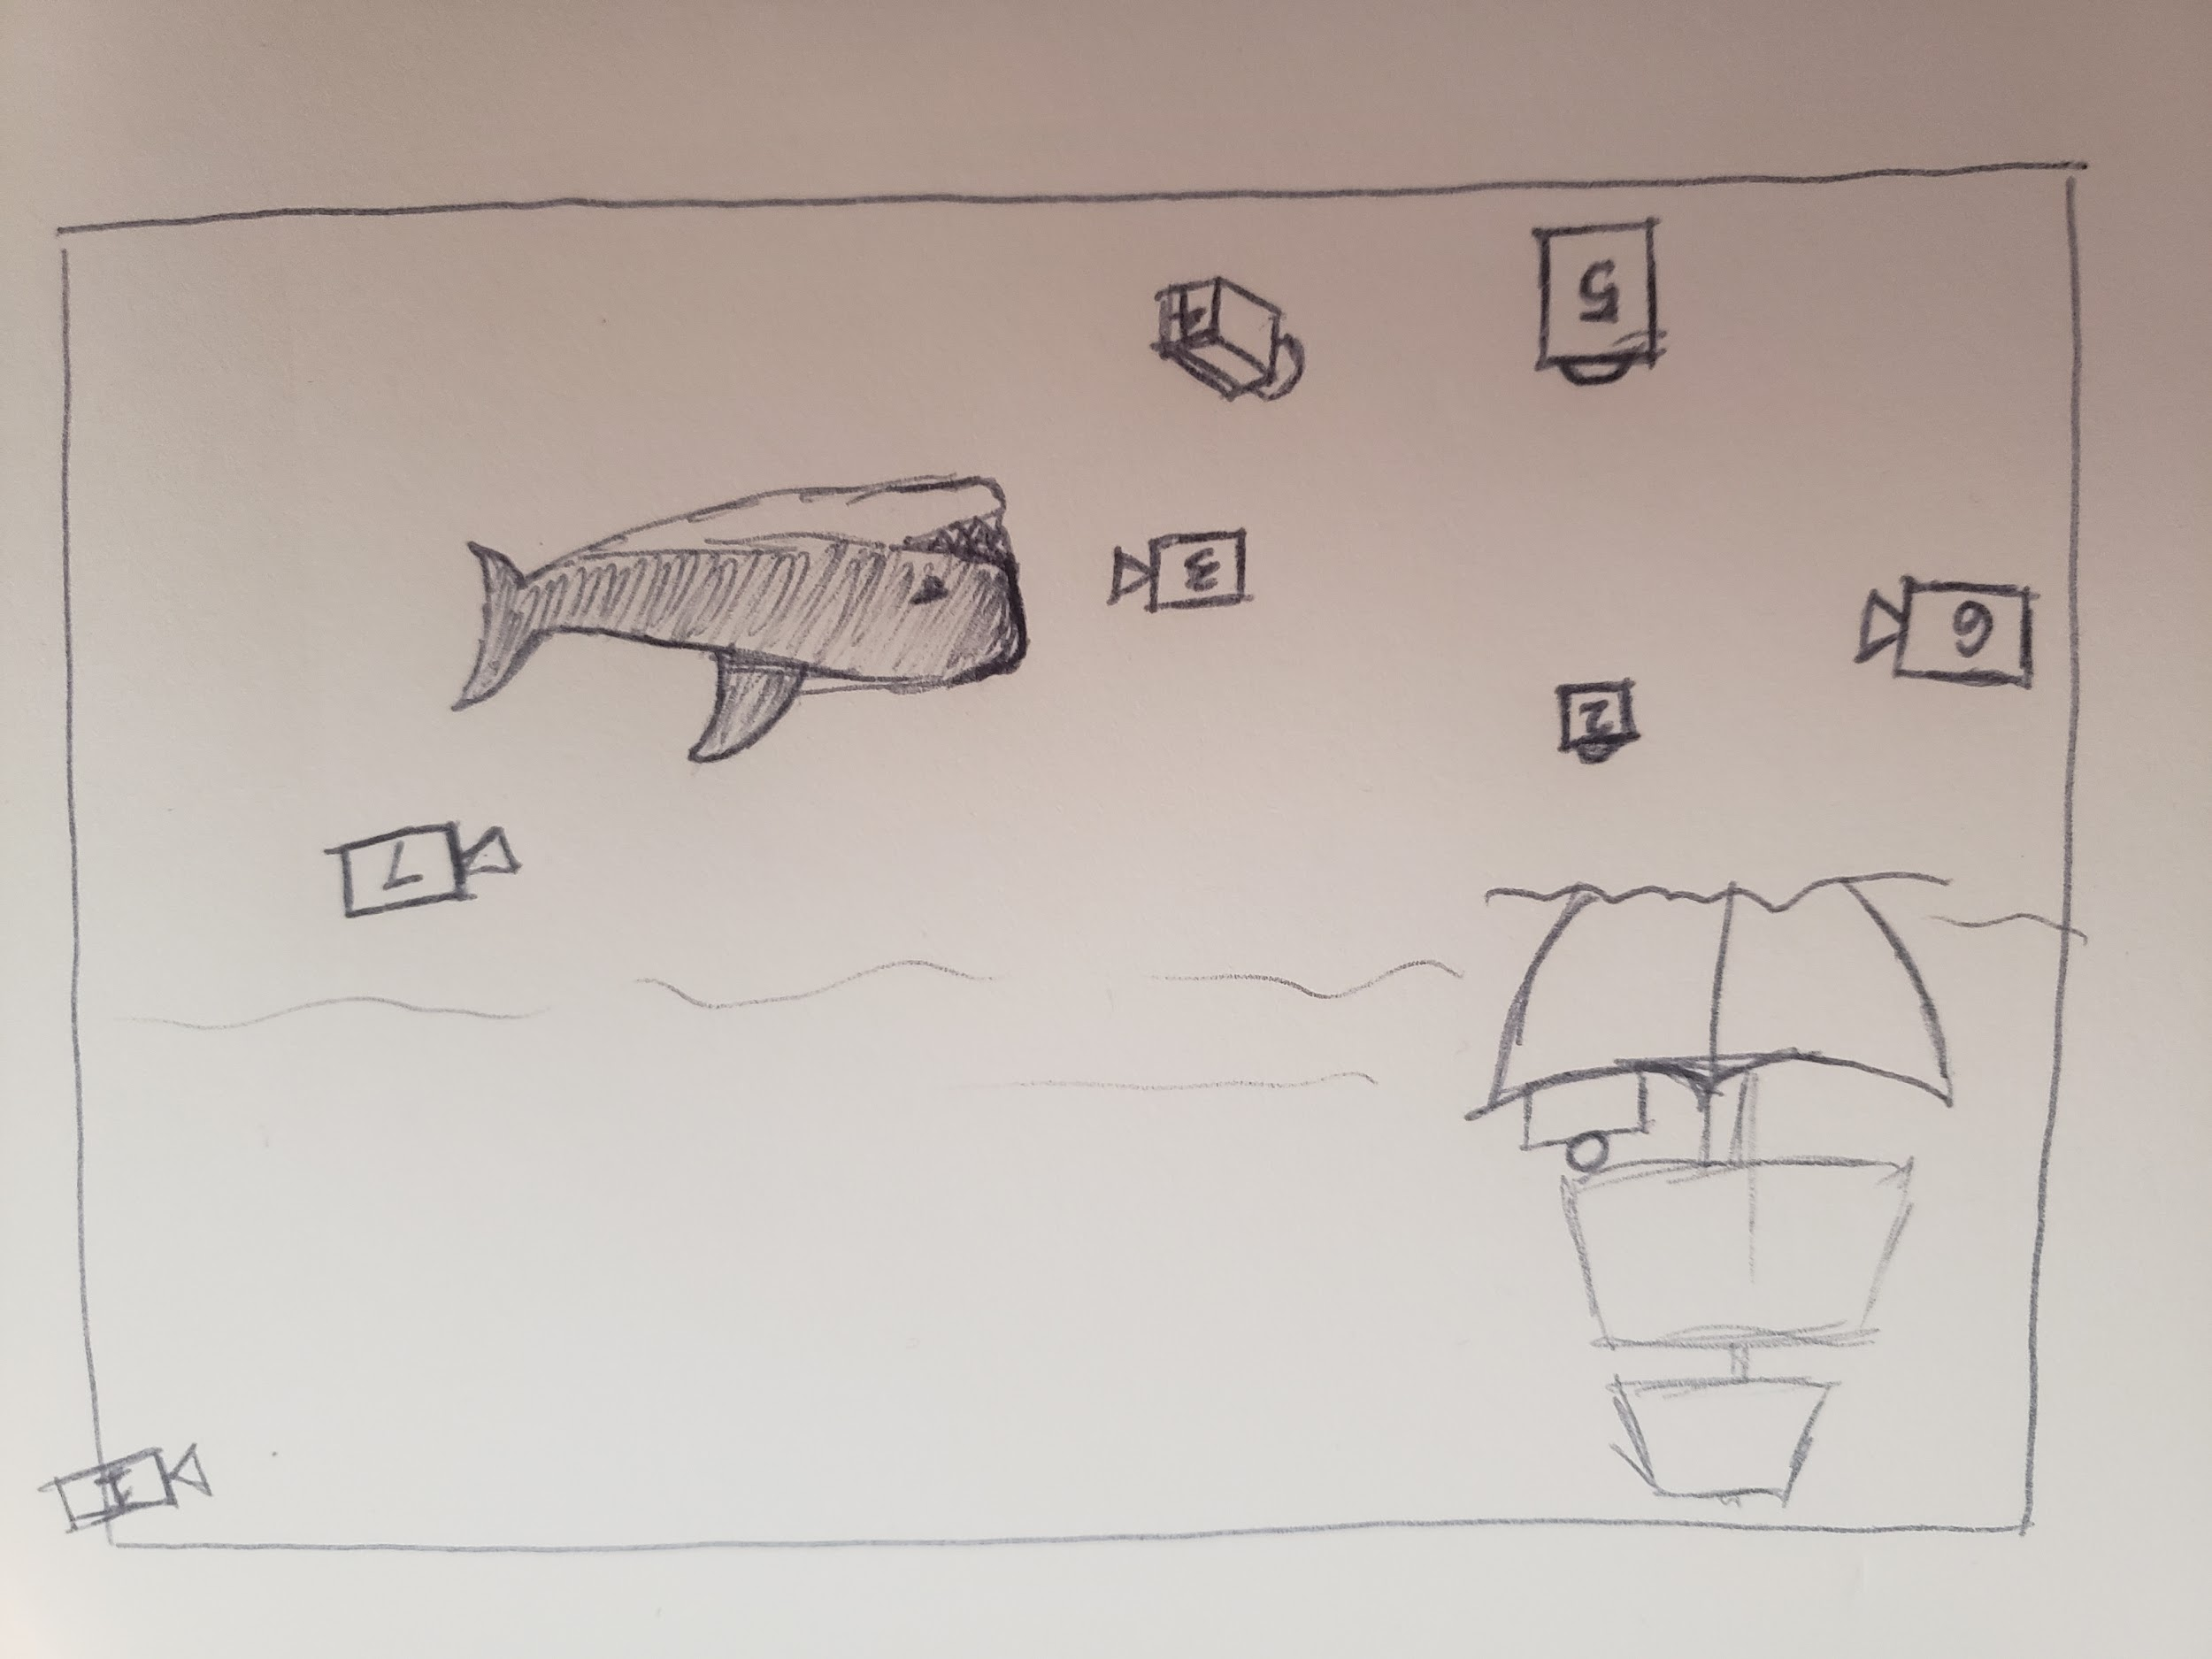

### Program Design

When thinking about planning out the program it was obvious that there were a lot of places where multiple things happened at the same time, such as a camera move while a character was moving, or an audio change with a camera move, so using a flow chart was the easiest way for the student to think about how to program this animation.

#### Flow Chart

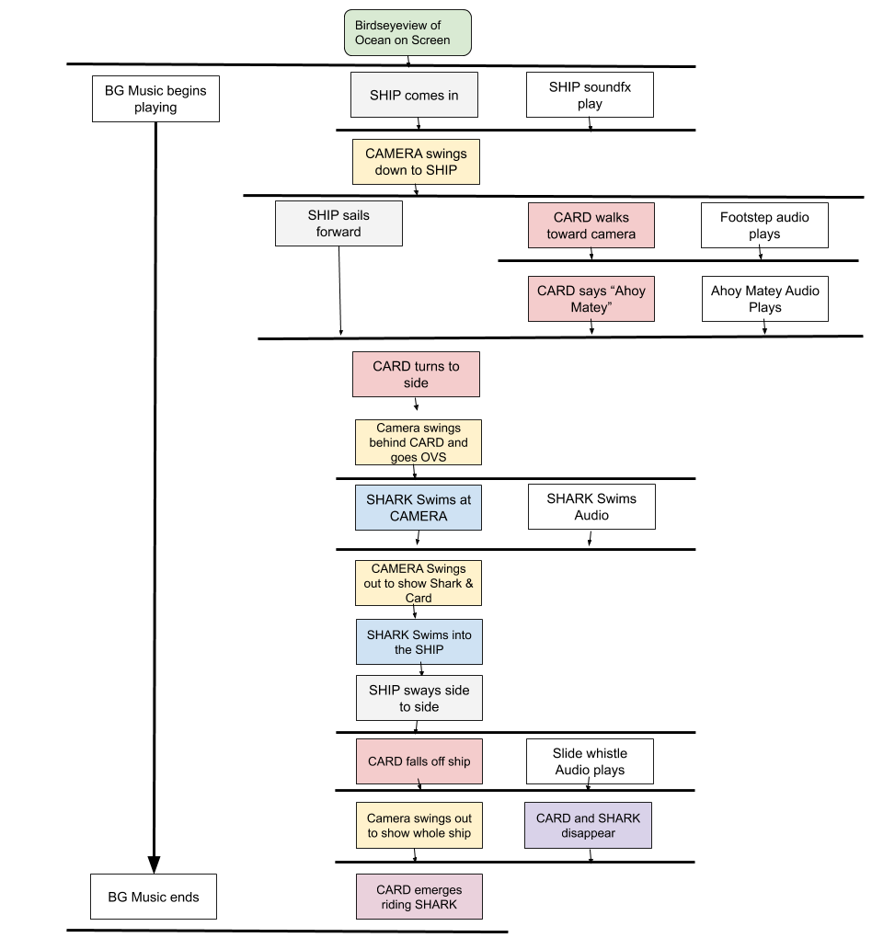

# Step 4: Implement the Design

The first step for implementing the design was to add comments to the program to outline what was to be created. We highly recommend doing this step to make it easy for you to see what you are creating and for others to be able to decipher your program and help debug it.

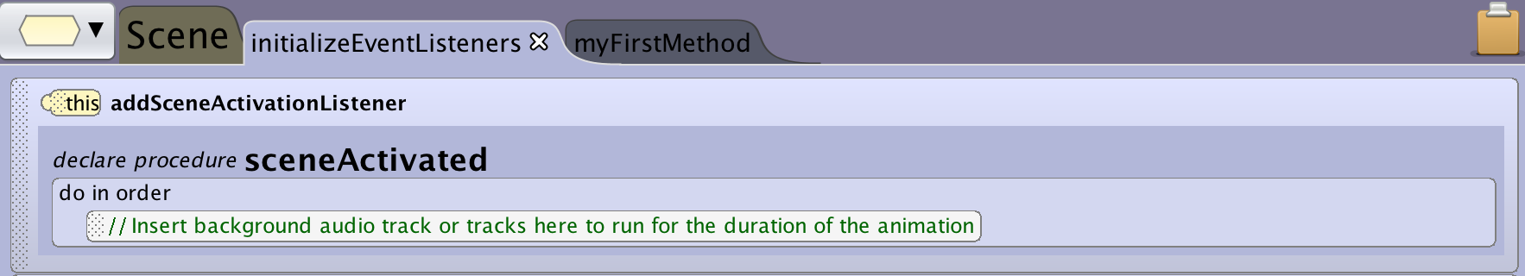

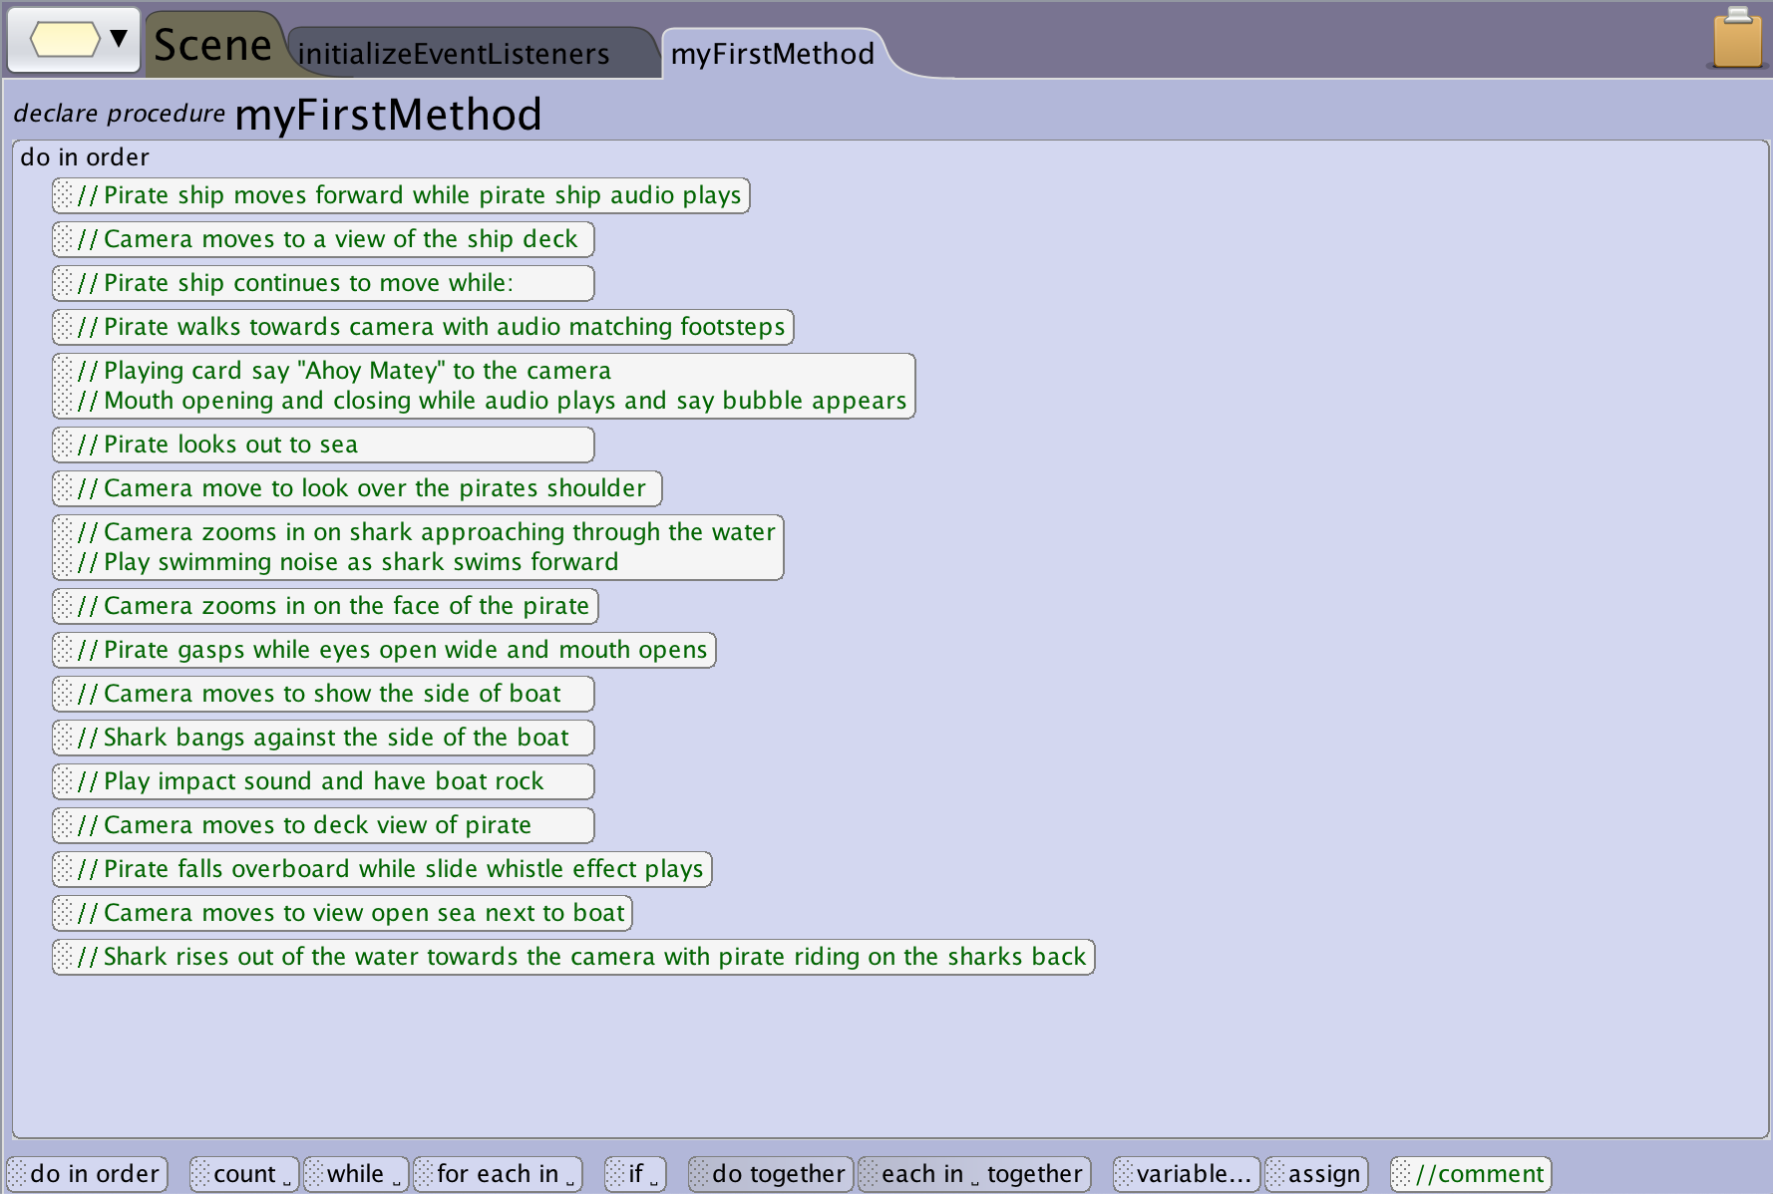

The student actually created the how-to videos for implementing audio during the production of this project. You can see how this was done in the Audio section of the how-tos resources including the use of audacity for creating the custom audio components.

# Attachment: Design Document

The above is showing the students work through each stage of the design process. This section is the actual document that was created during the process. This document was a living document that was updated each time new feedback was incorporated and the components were edited so that it would always reflect the most recent design.

### Title

Sea Encounter

### Story Concept

Our story starts with the playing card pirate aboard his ship. The pirate ship is attacked by a Great White Shark, sending the Playing Card Pirate into the sea. Just as the audience thinks the Playing Card Pirate has reached his demise, the Pirate emerges from the water, riding the Shark over the waves.

### Creative Design

#### World Design



#### 

#### 

#### 

#### Storyboard



#### Script

OPENING: CAMERA looking down and filling the frame with blue water. Large SHIP with sails is entering the top of the frame. Wind and water sounds playing. Sea shanty music fades in.

(SHIP sails into the middle of the frame. CAMERA sweeps down to eye level with the ship deck. Water and wind sounds fade out.)

(CARD is in the camera frame and walks toward the camera. Footstep sound effects as he walks. Music continues playing.)

CARD: Ahoy Matey! (To camera. Speech bubble appears on screen with text. Voice recording for audio plays.)

(CARD turns to look over the side of the ship out to sea.)

(CAMERA swings behind CARD and over CARD shoulder toward the sea. Camera pauses.

(Music changes to Jaws-like theme.)

(SHARK swims toward the boat. Only Dorsal fin and tail fin are visible and sticking out of the water.)

(CAMERA zooms in on a shark as it nears the ship.)

(CAMERA turns toward CARD. Music changes to dark and threatening.)

(CAMERA zooms in on the card face.)

CARD (looking shocked): GASP

(CAMERA pans out to show SHARK, and SHIP)

(SHARK forcefully collides with SHIP and rocks SHIP. Collision sound effects.)

(CAMERA pans up to CARD)

(CARD falls overboard. Splash sound effects.)

(CAMERA pans out to show ship and ocean.)

(CARD and SHARK emerge from water and enter the bottom of the frame. CARD is riding the SHARK. Splash sound effects. )

(CARD and SHARK move toward the camera and exit top of frame. Music changes to a more upbeat sound.)

ENDING: SHIP in view. Screen goes black.

### Technical Design

#### Program Flow Chart

